**WS06- GITHUB TESTING**

**DATE:** 15th november 2021

**GITHUB TESTING**

1 ALMACHE LITARDO ANDERSON MOISES

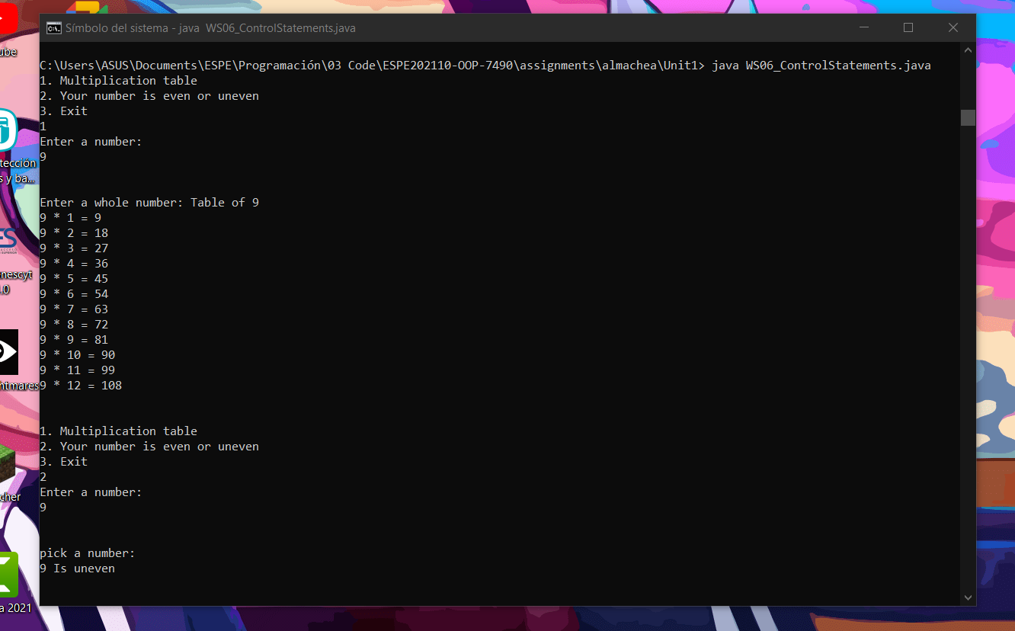

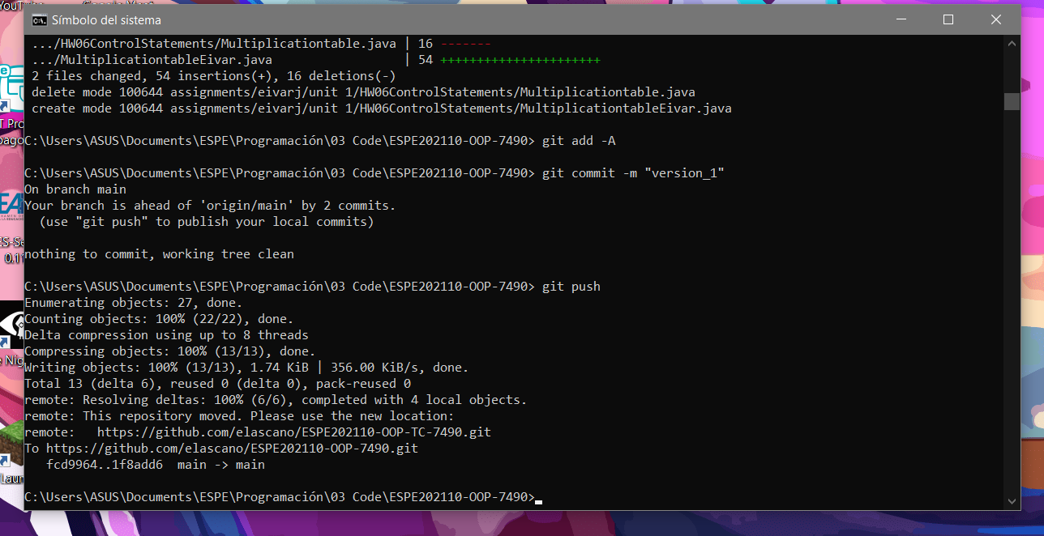

2 ALTAMIRANO BENALCAZAR CRISTHIAN ALEXANDER

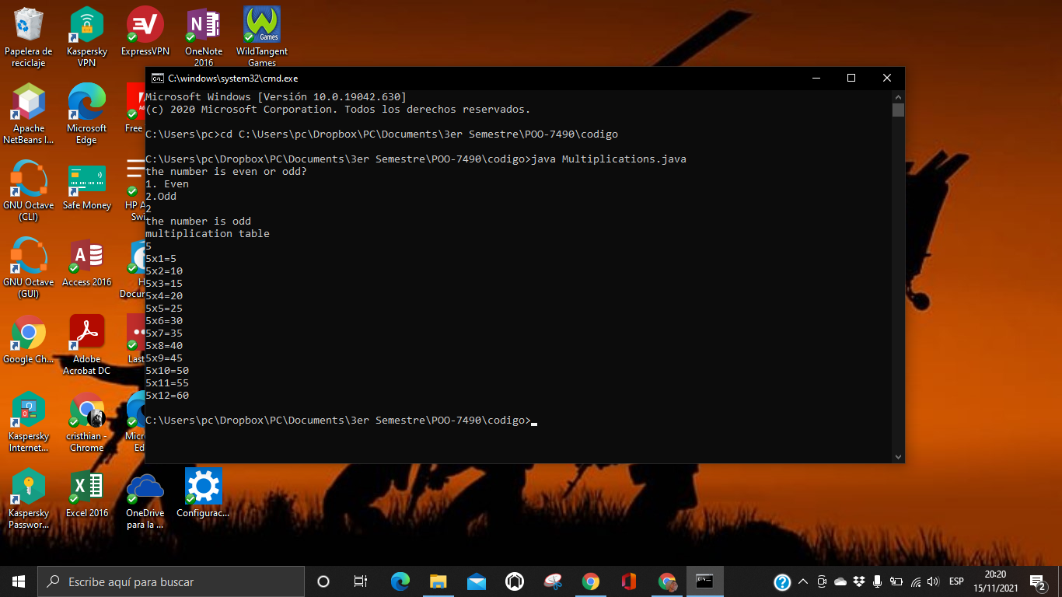

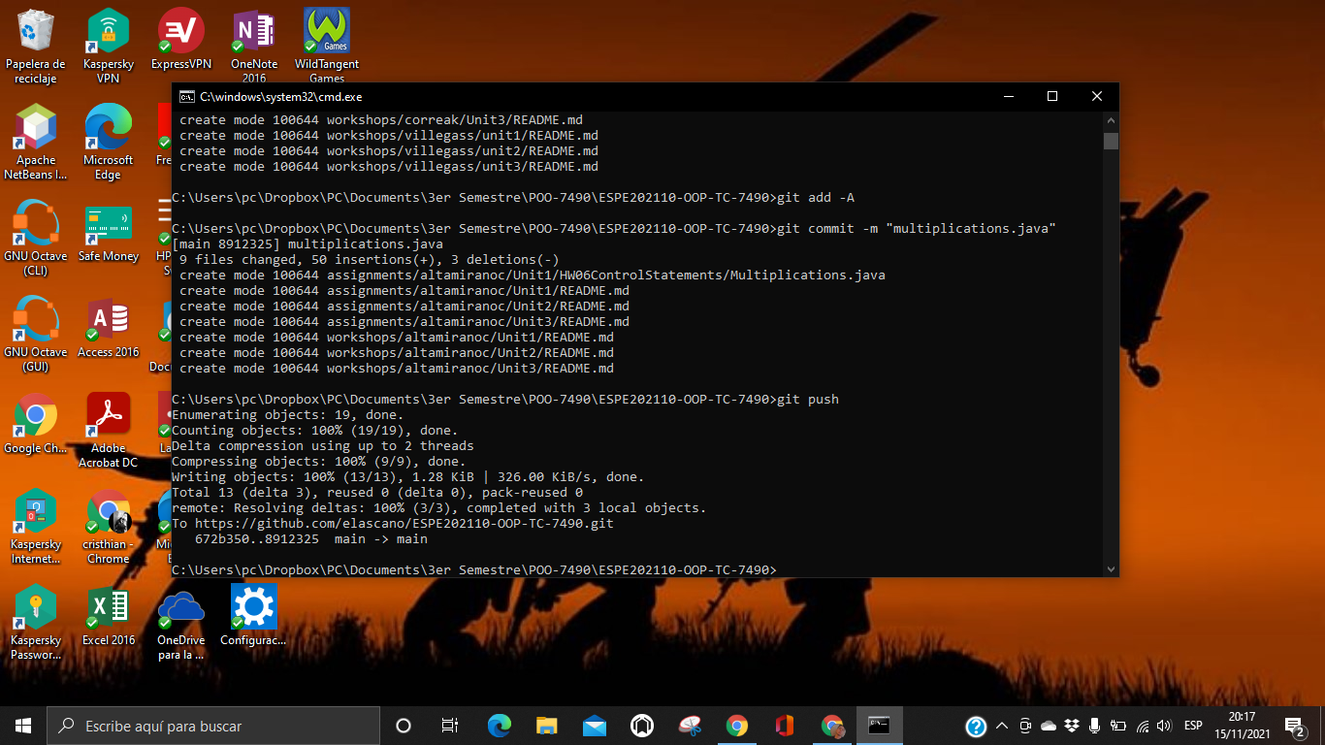

3 ALVAREZ RAMIREZ MICHELLE ESTEFANIA

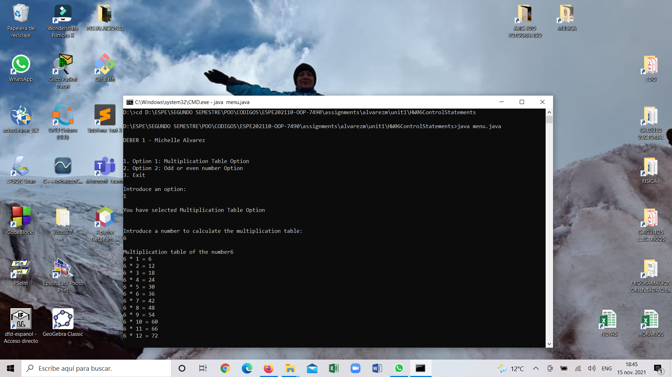

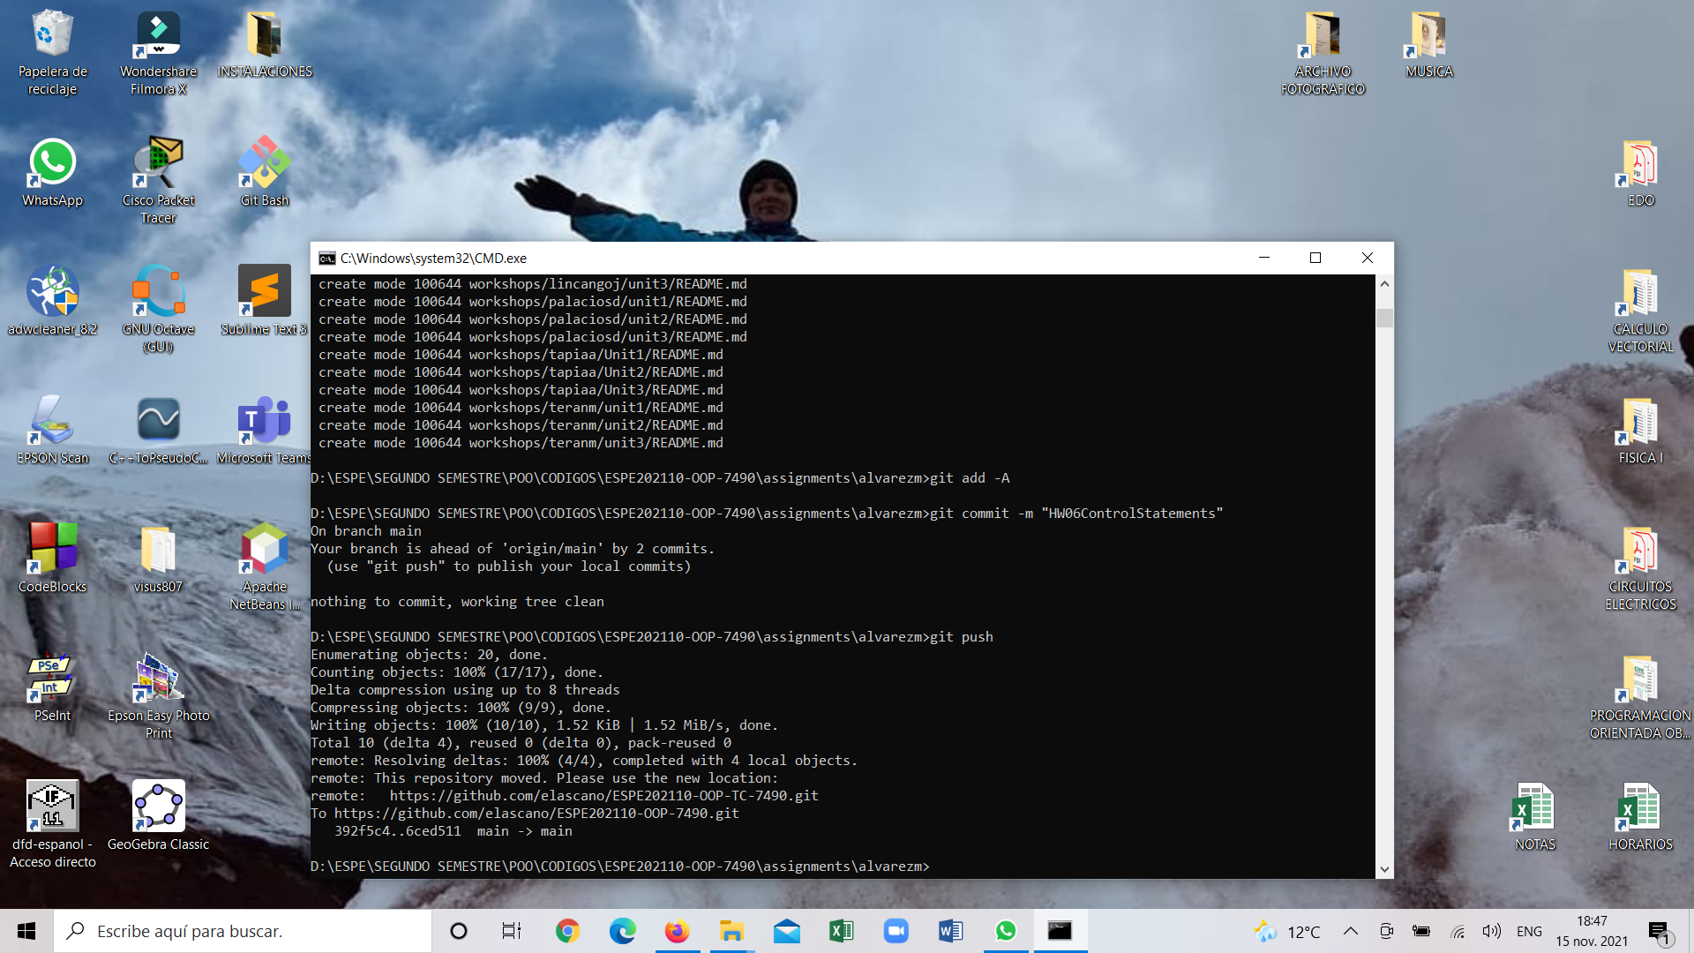

4 ANDRADE CARATE ALAN DAMIAN

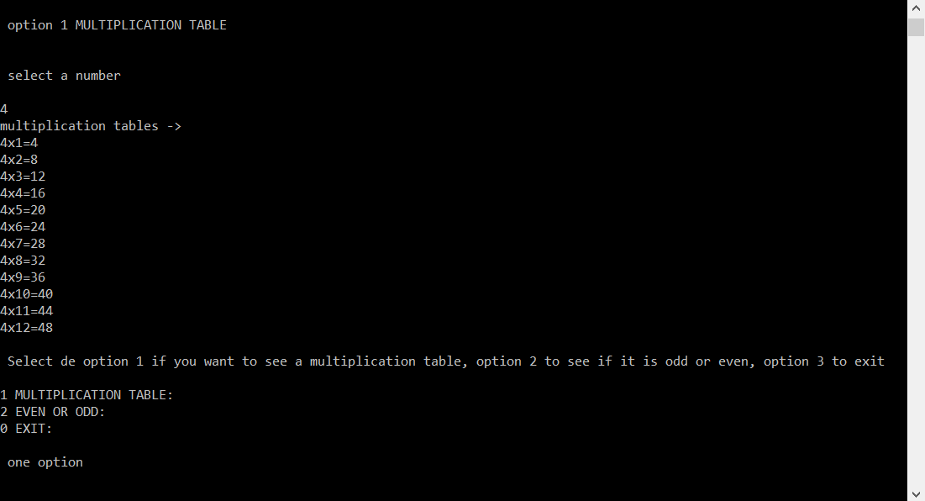

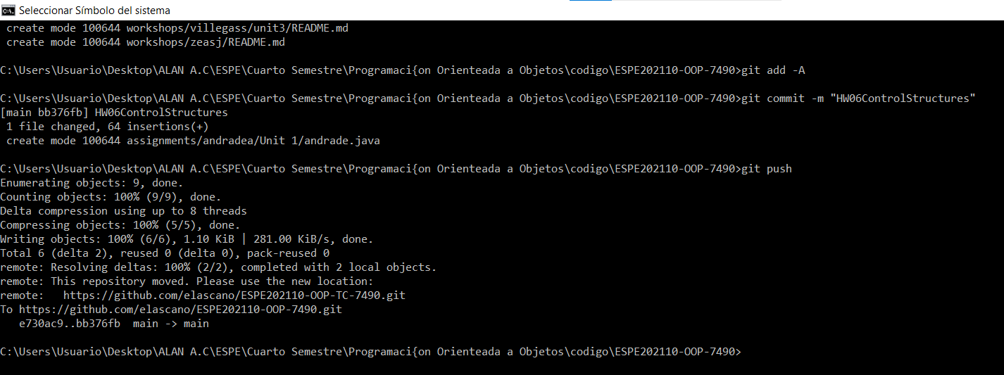

5 ANDRANGO ESPINOSA ALEX PAUL

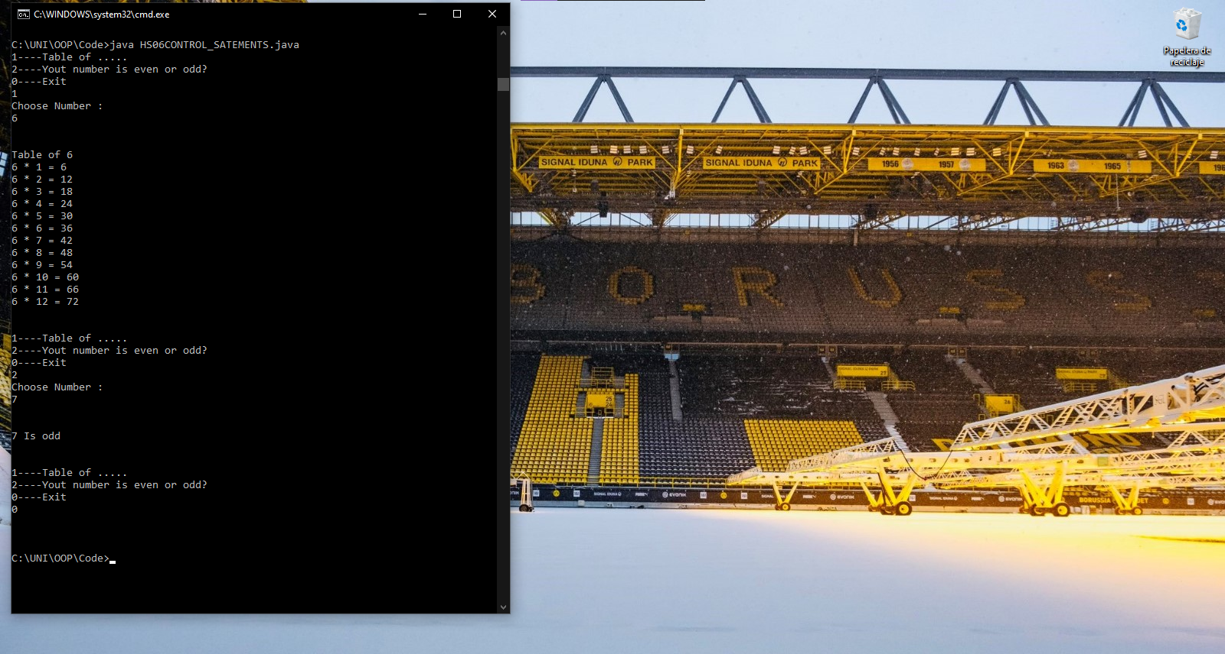

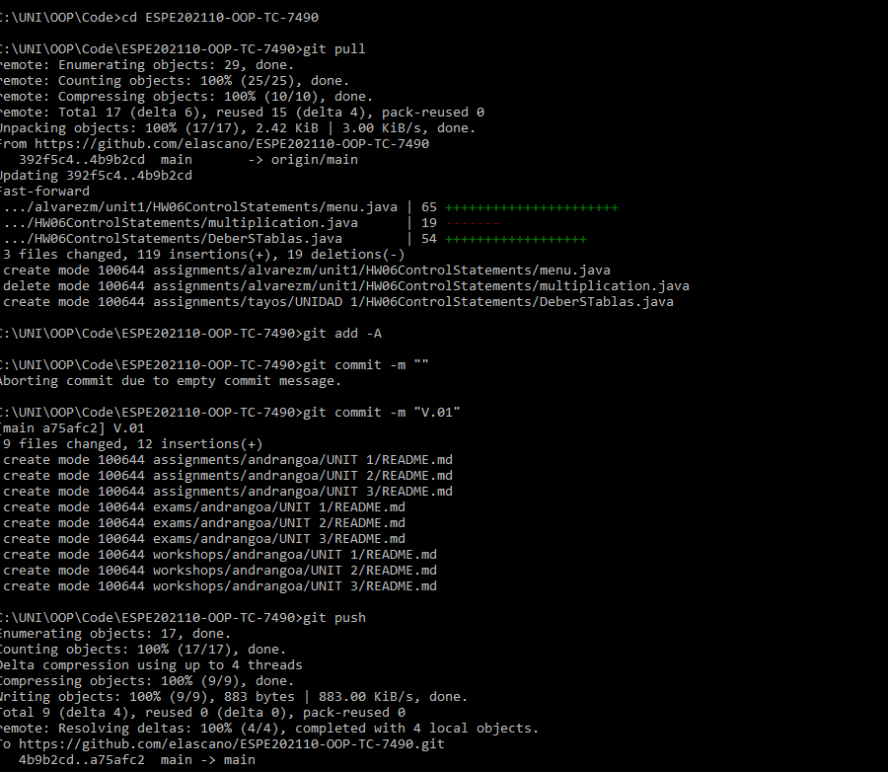

6 ARROBA SOLORZANO CRISTIAN ALEXANDER

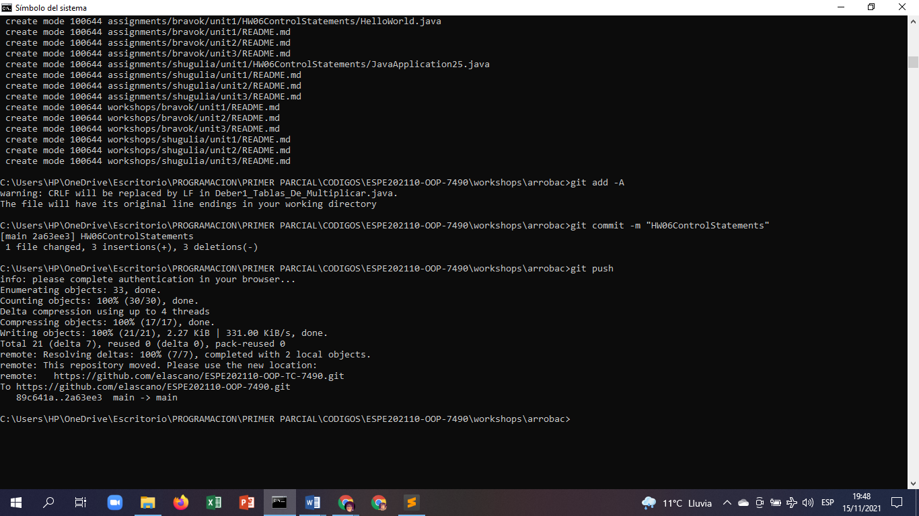

7 ASUMAZA GUALOTO DYLAN ALEXANDER

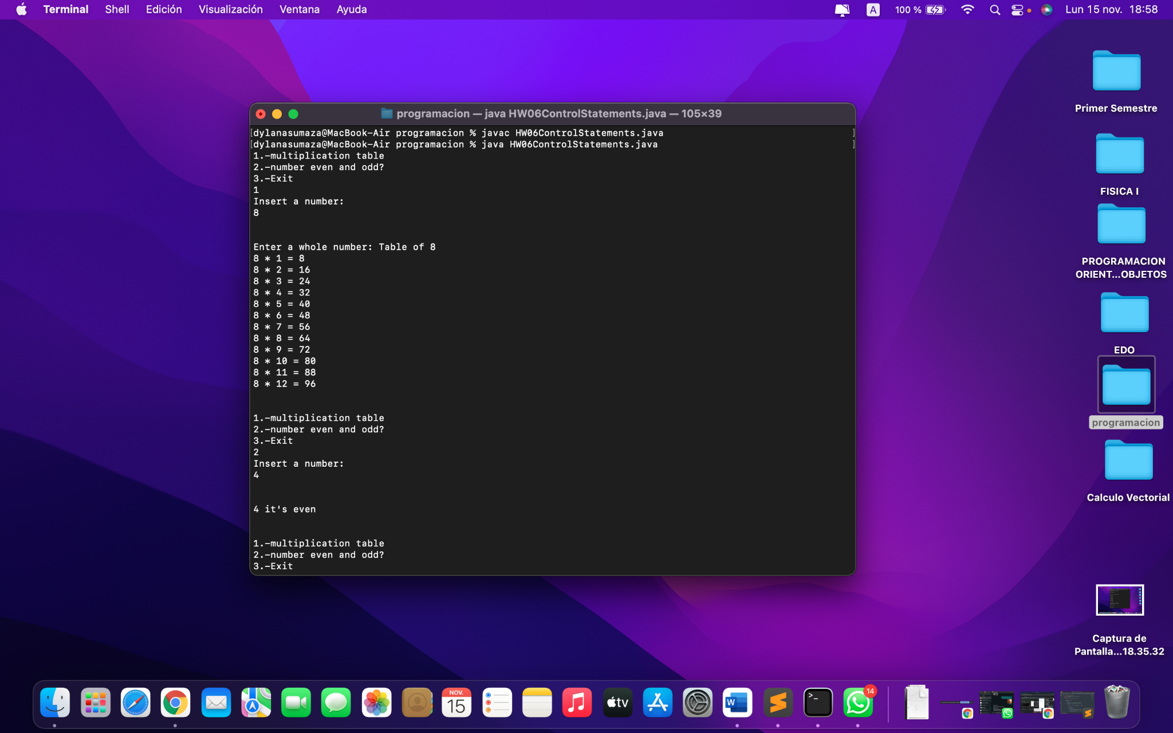

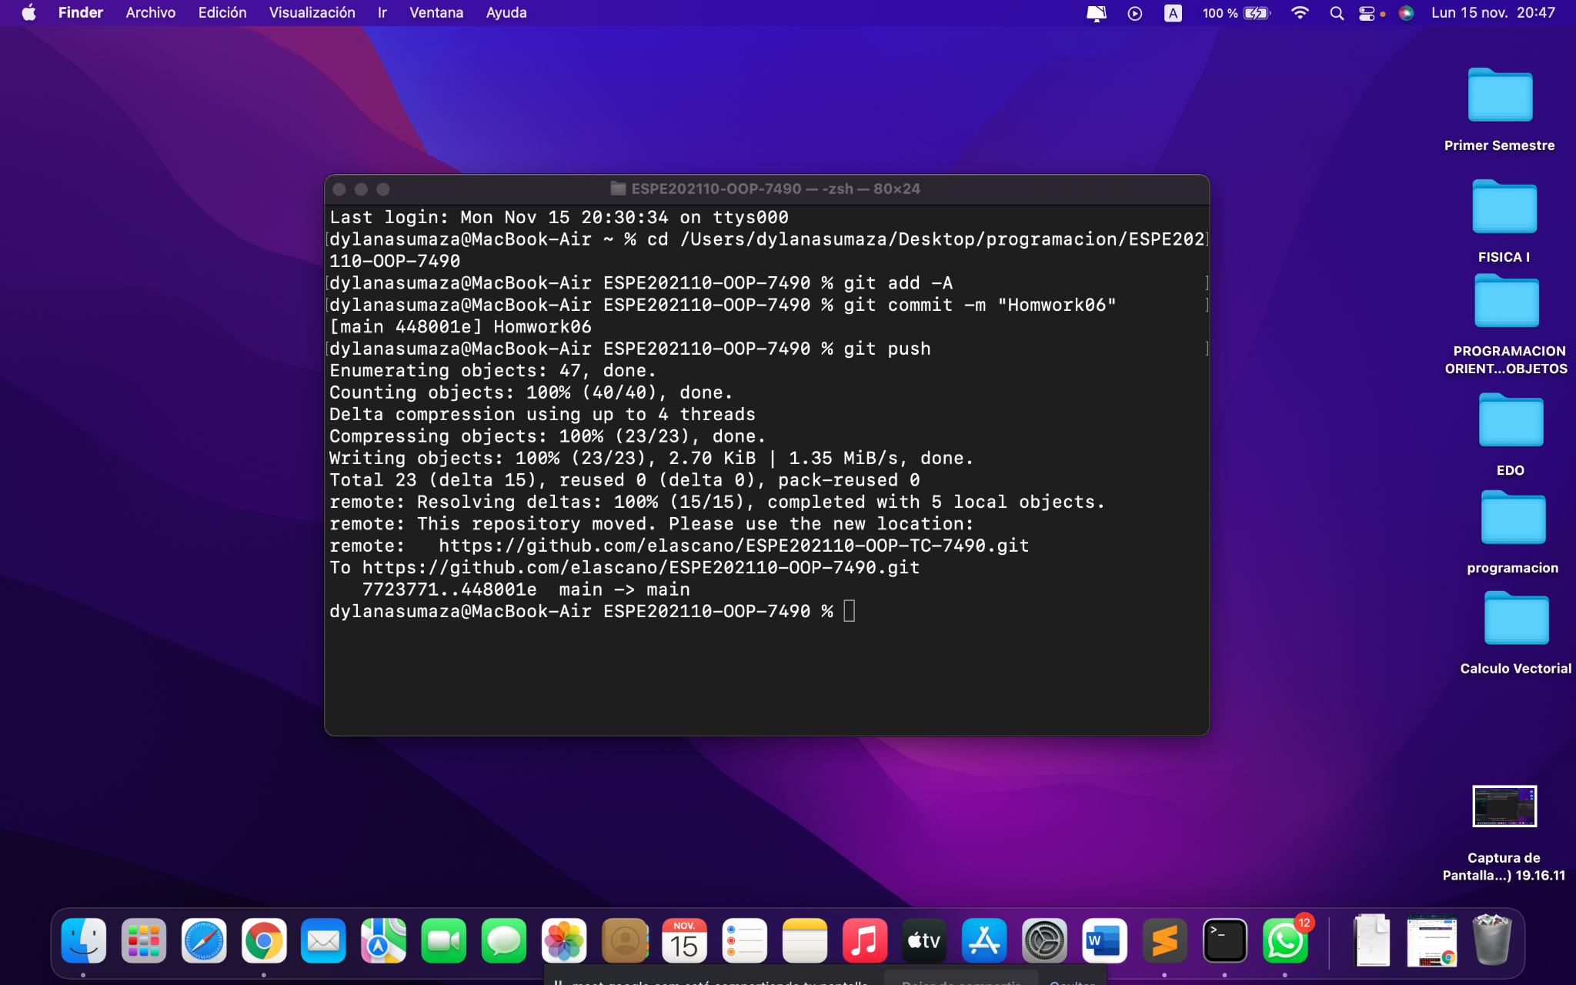

8 BRAVO RODRIGUEZ KATHERIN DAYANNE

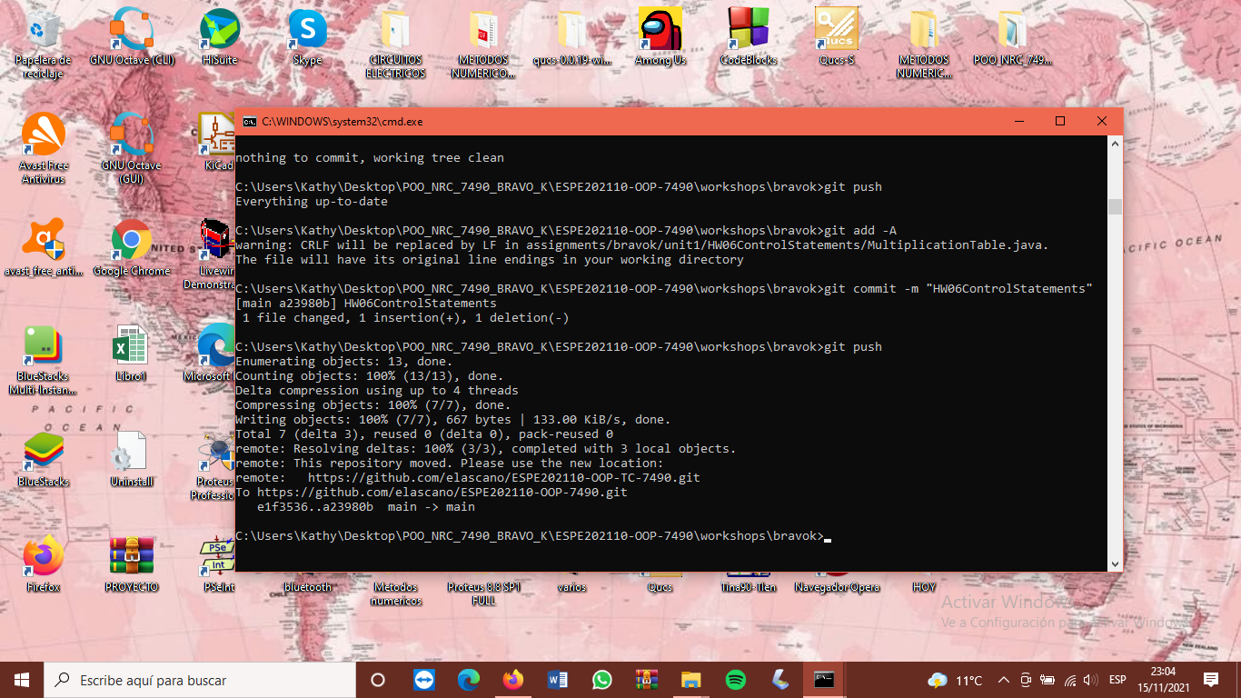

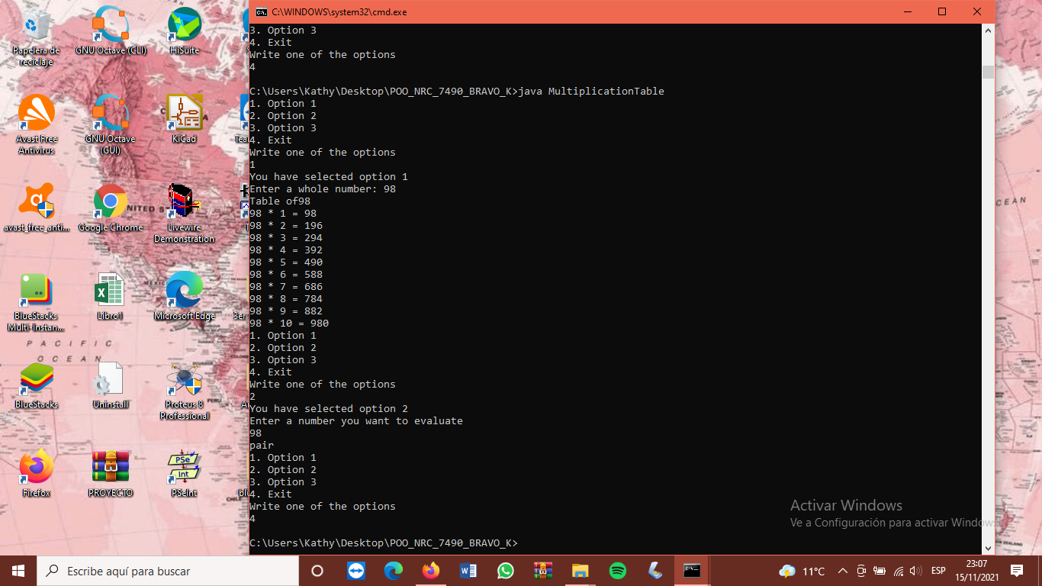

9 BRAVO VILLALOBOS CHRISTIAN DAVID

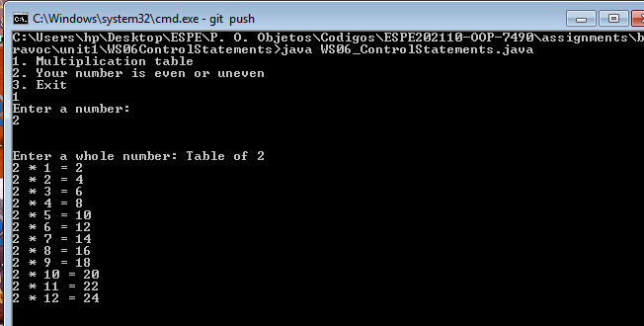

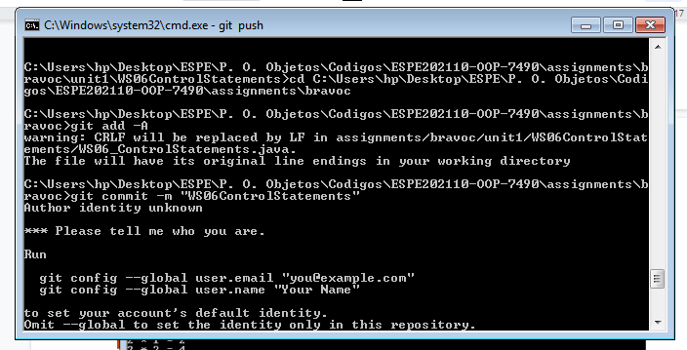

10 BUSTILLOS MONTENEGRO PABLO SEBASTIAN

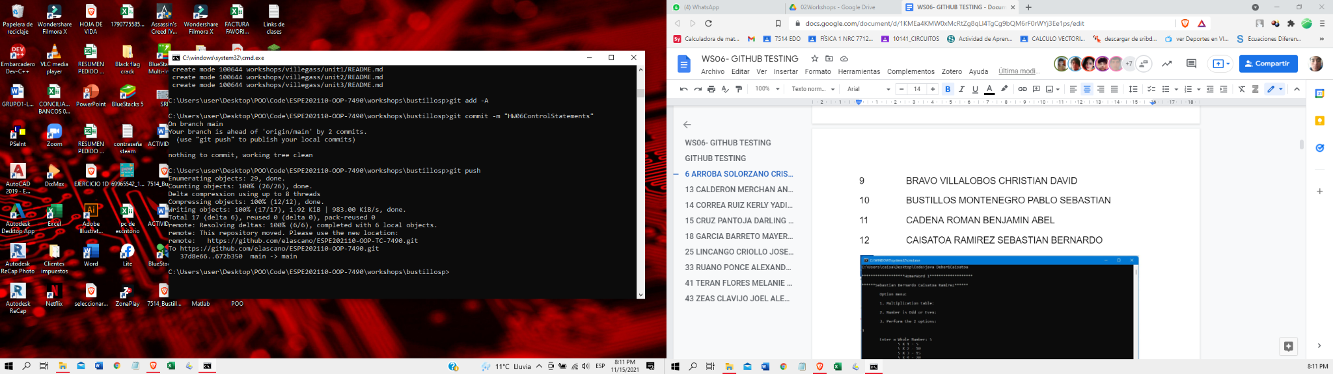

11 CADENA ROMAN BENJAMIN ABEL

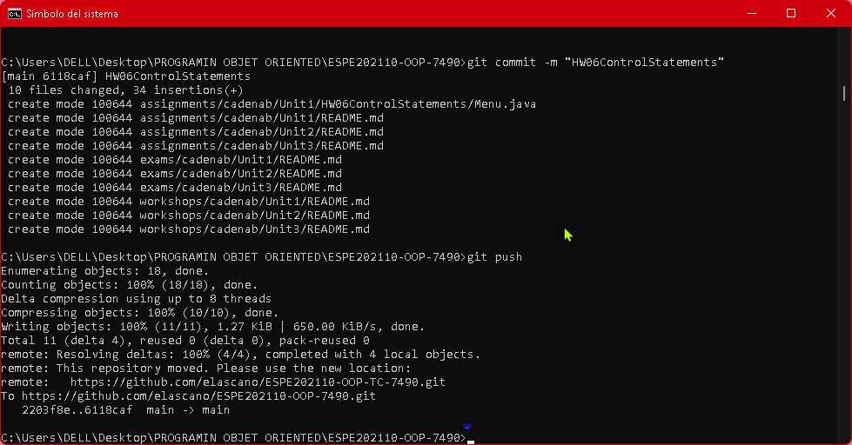

12 CAISATOA RAMIREZ SEBASTIAN BERNARDO

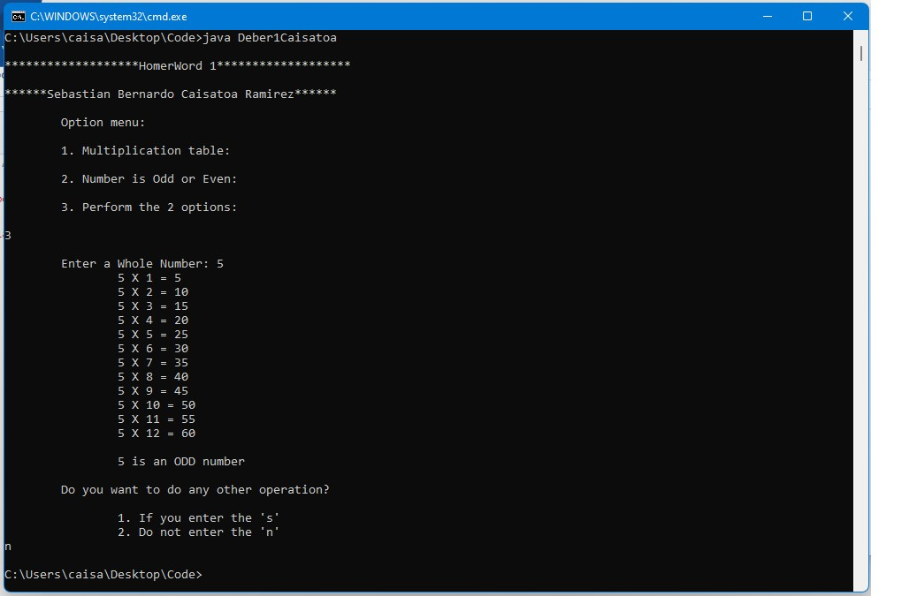

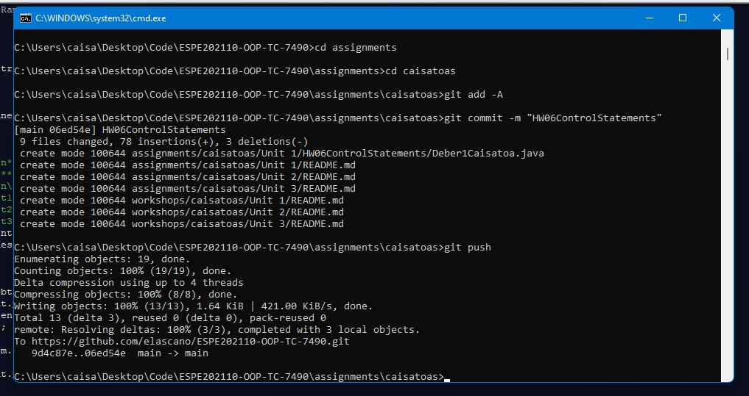

13 CALDERON MERCHAN ANDY JOSUE

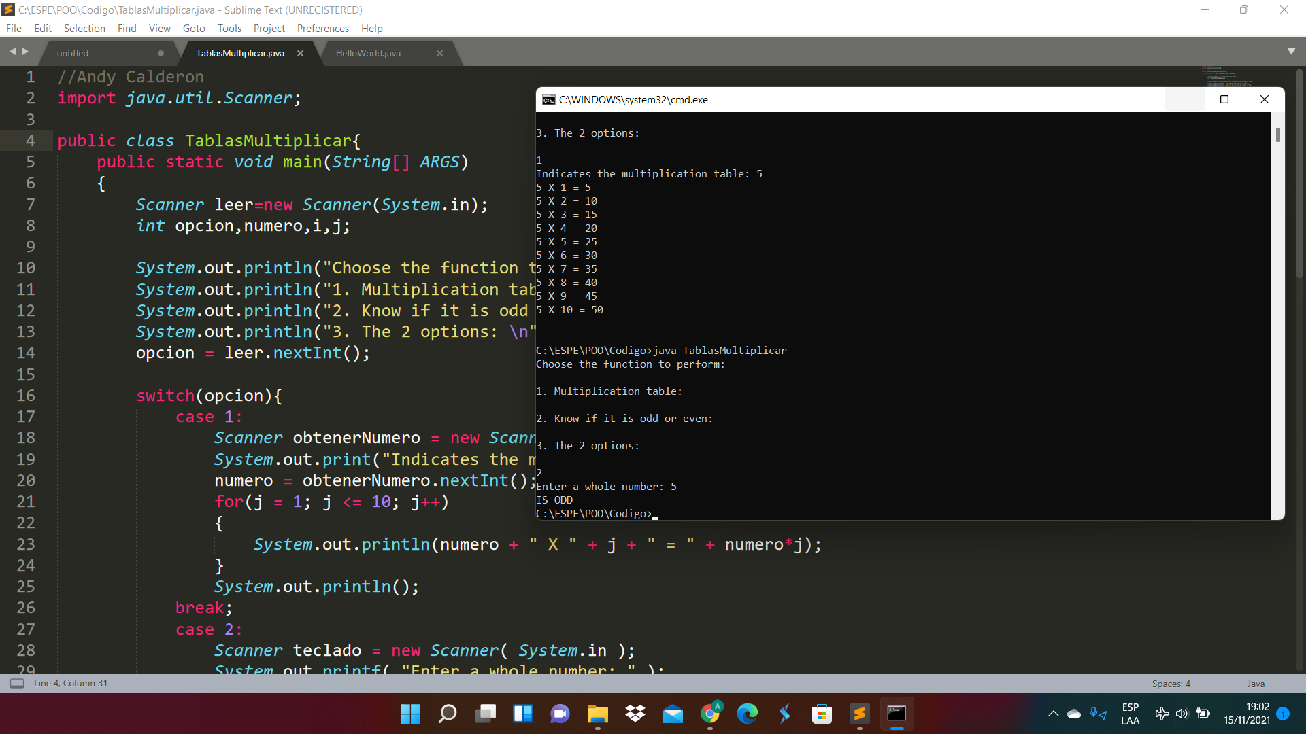

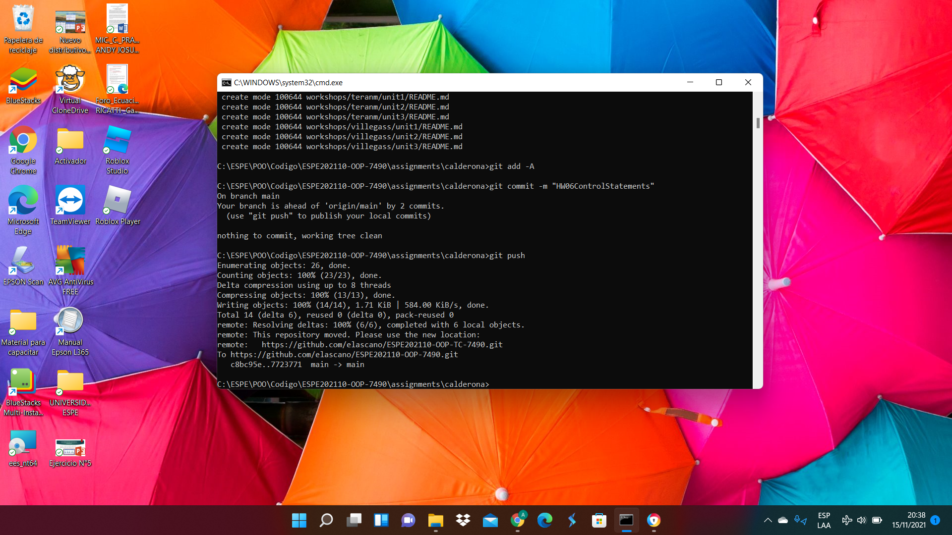

14 CORREA RUIZ KERLY YADIRA

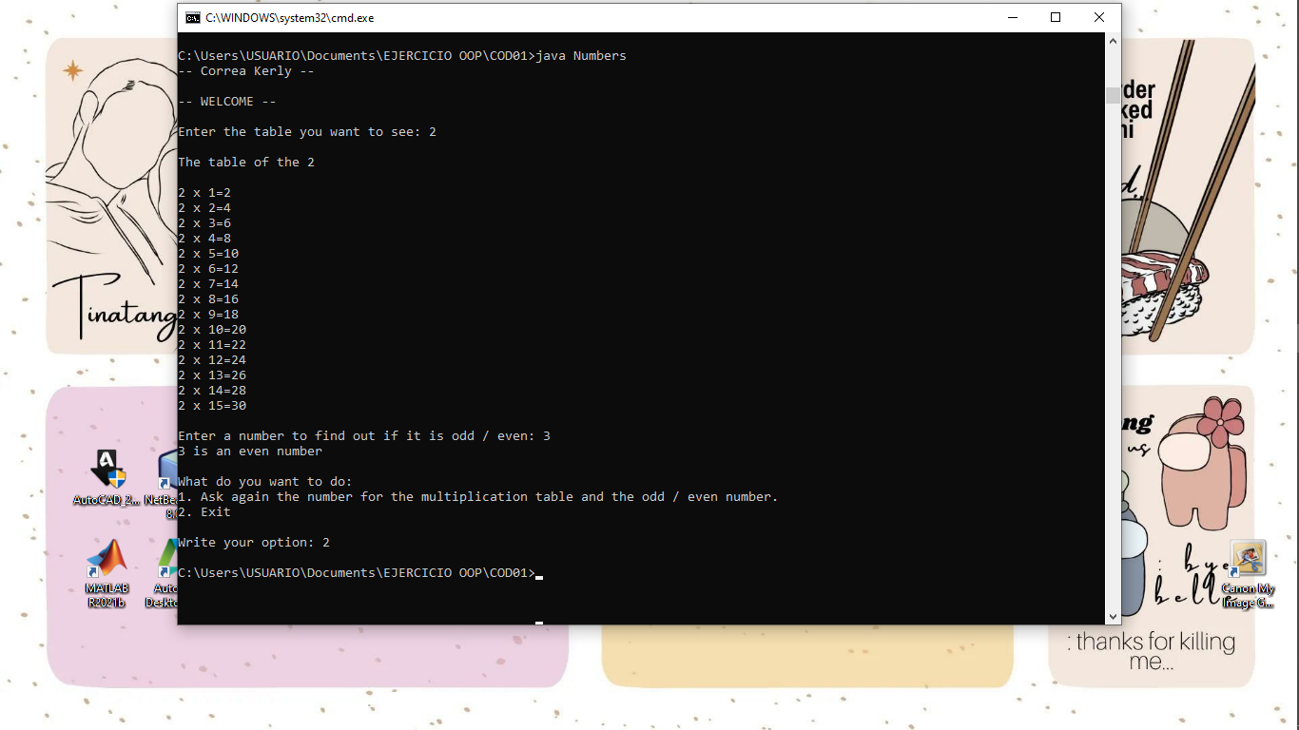

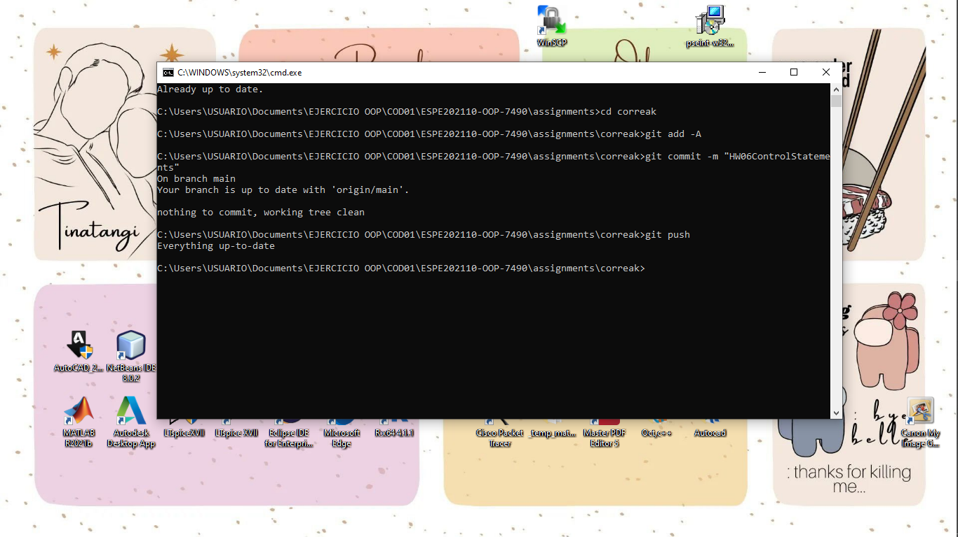

15 CRUZ PANTOJA DARLING MICAELA

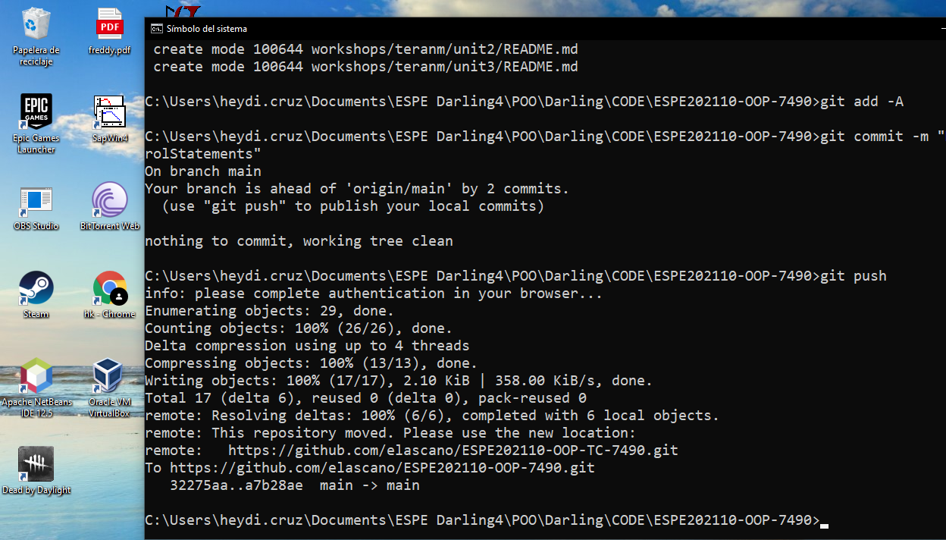

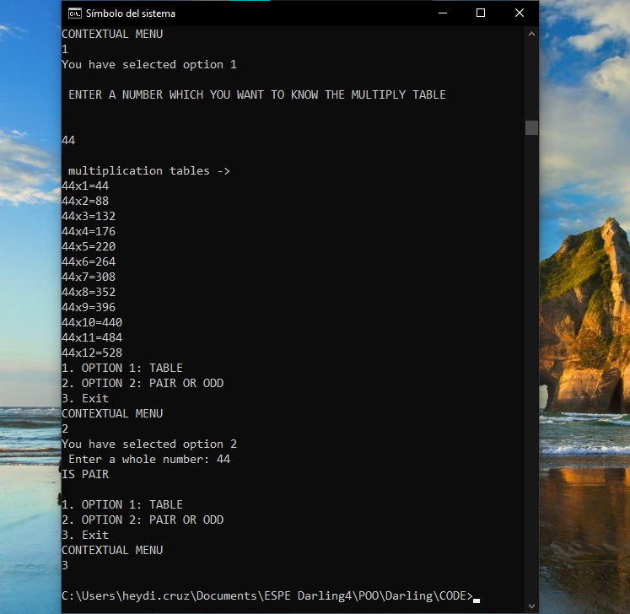

16 DE LA CRUZ QUINGA ALEJANDRO SEBASTIAN

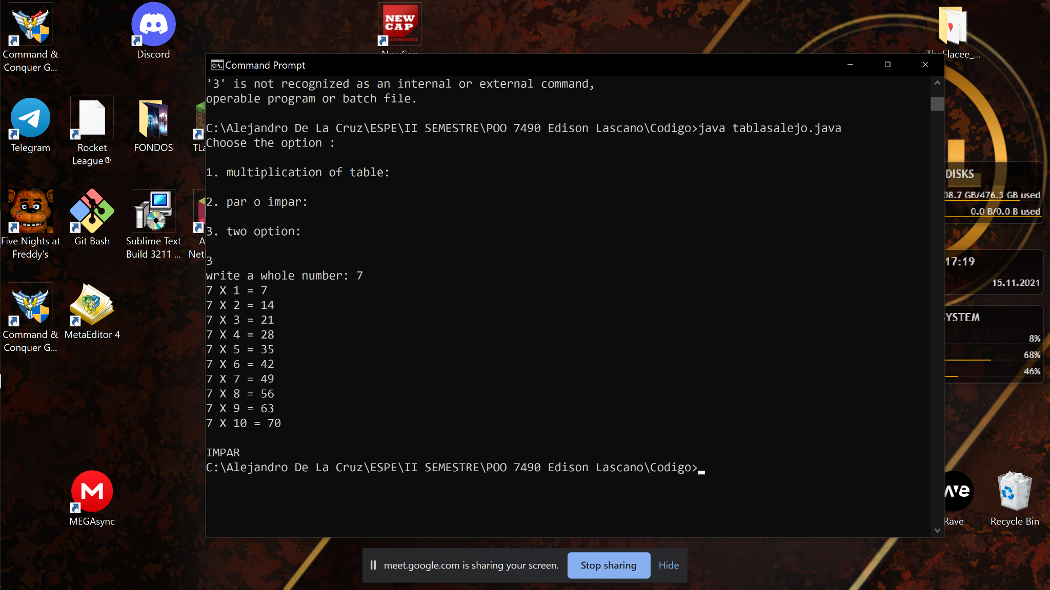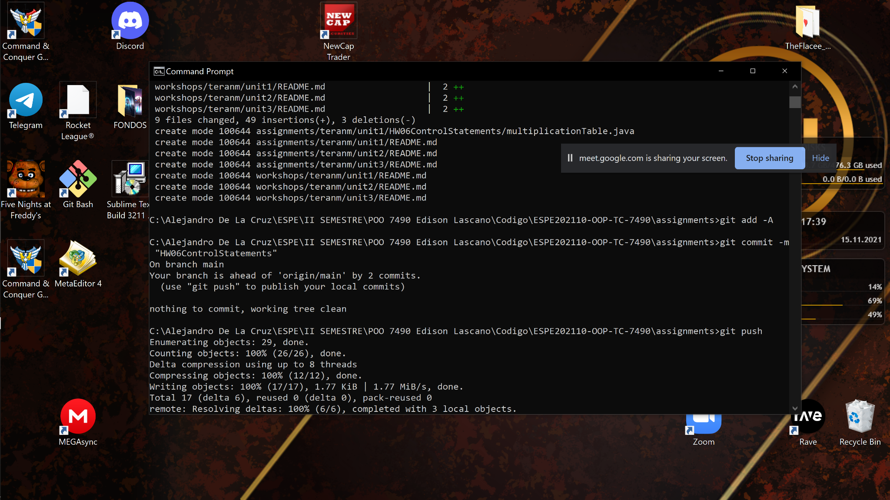

17 EIVAR DAGUA JAIME MAURICIO

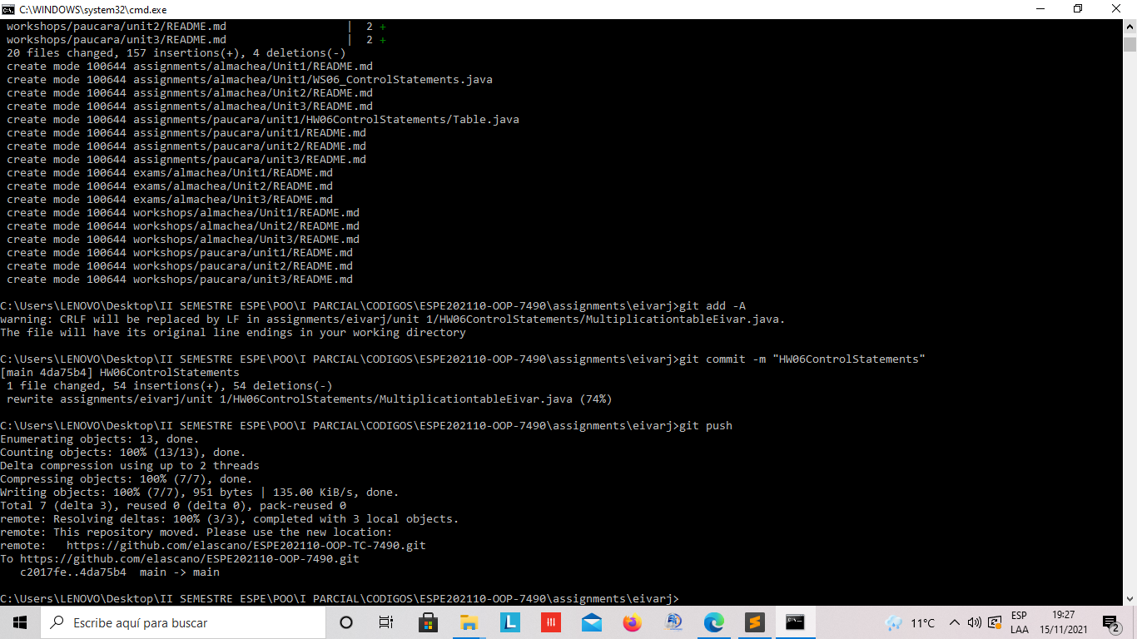

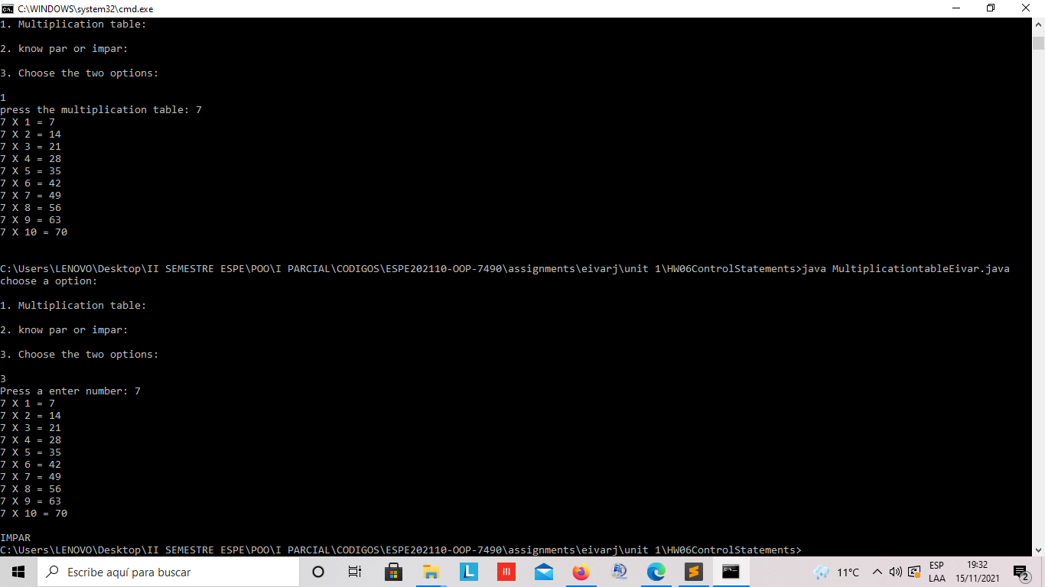

18 GARCIA BARRETO MAYERLY PRISSILLA

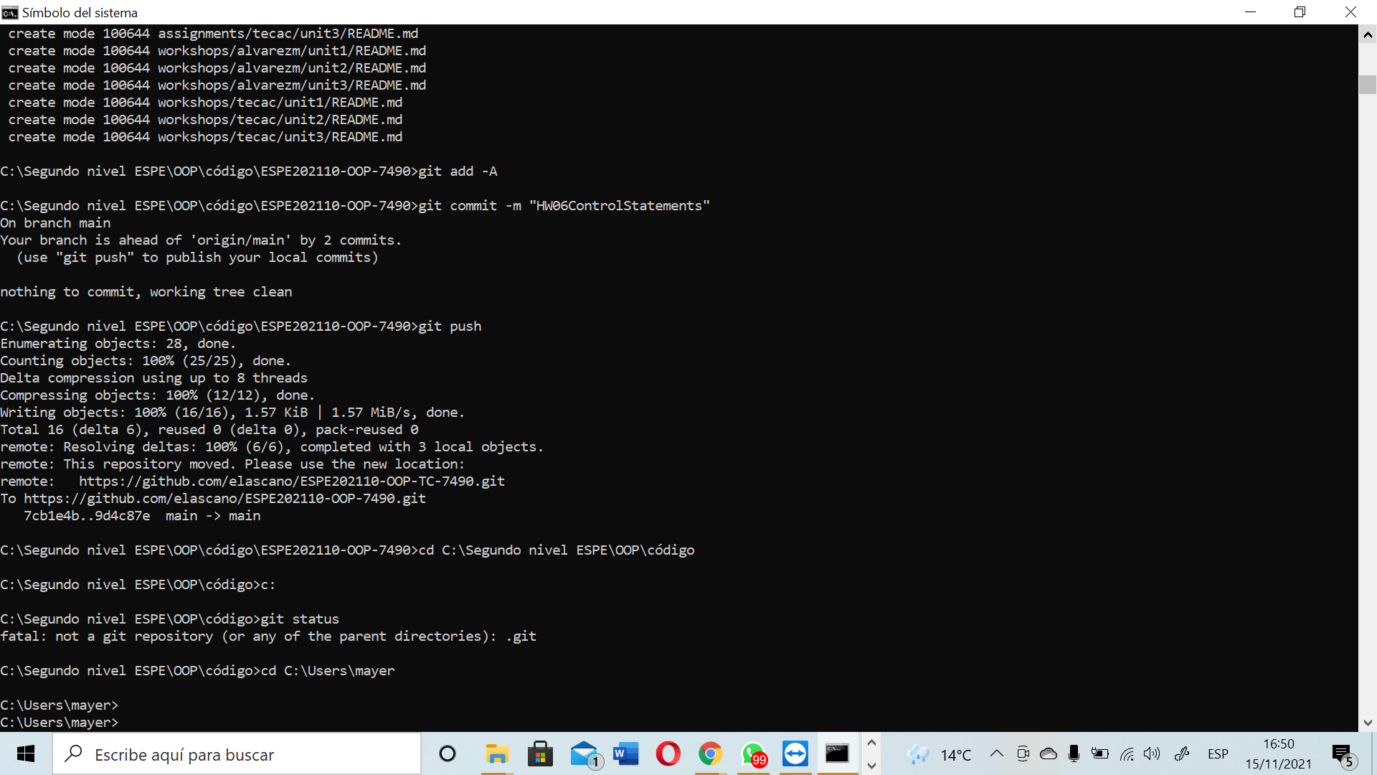

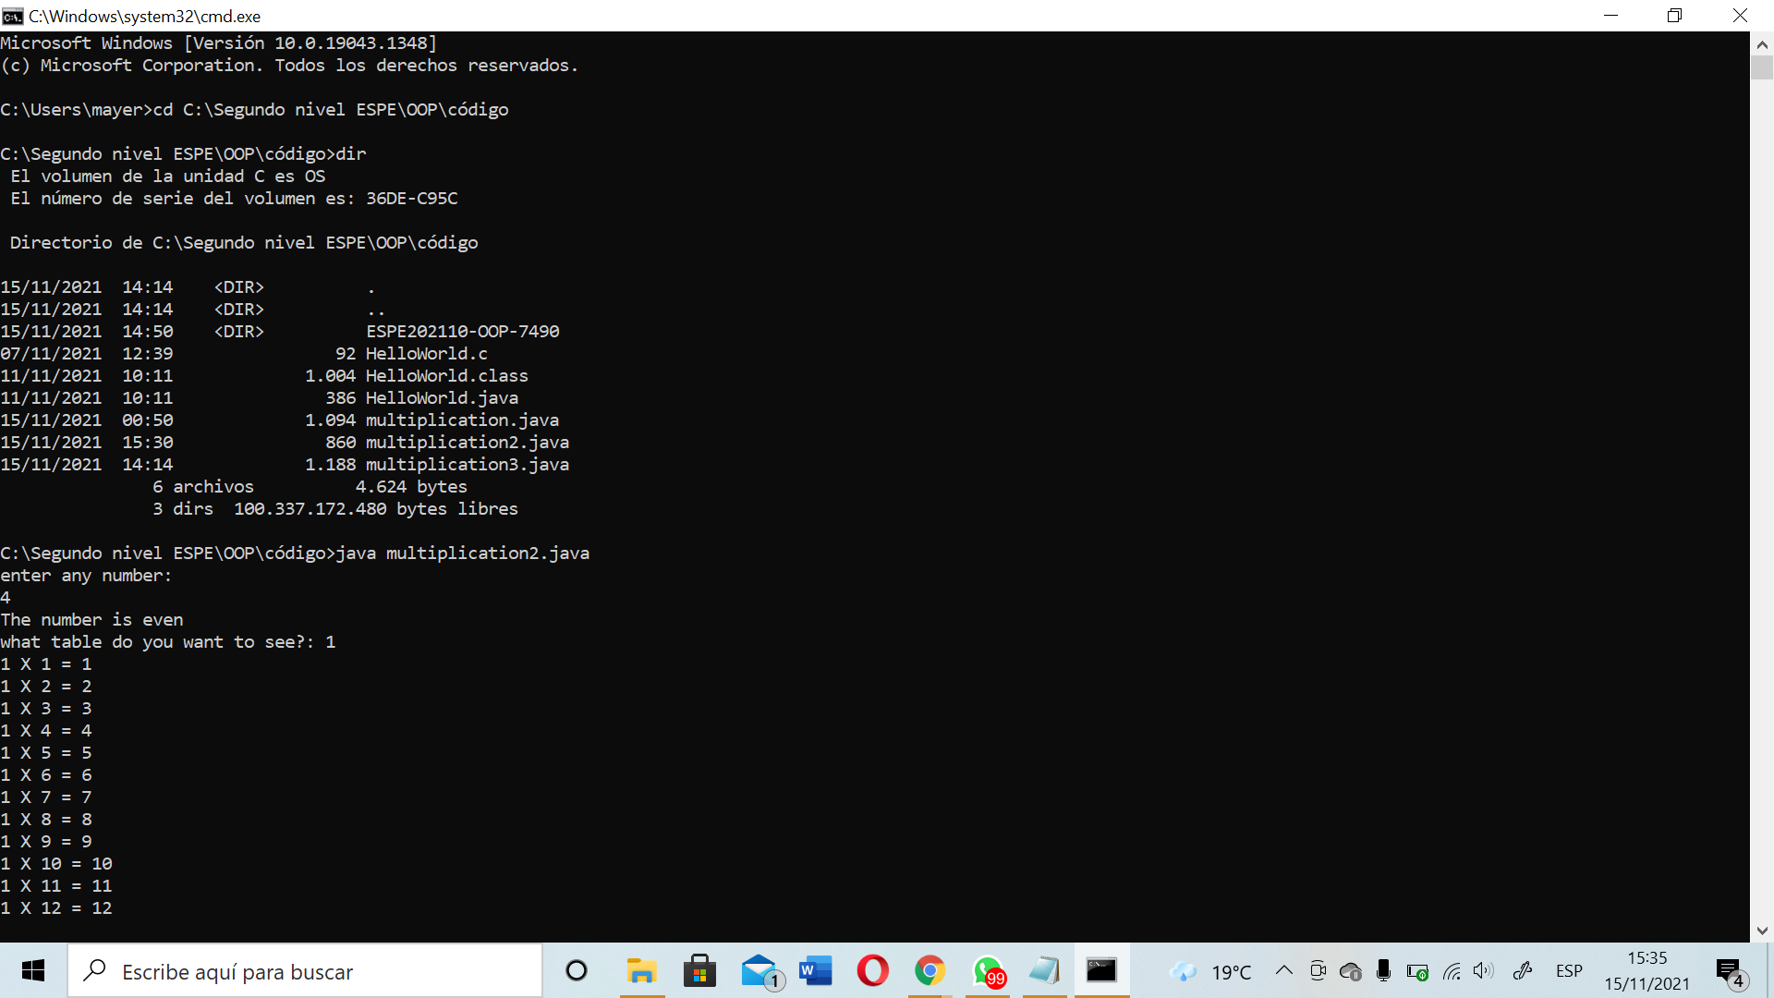

19 GOMEZ DIAZ MELISSA MALAYCA

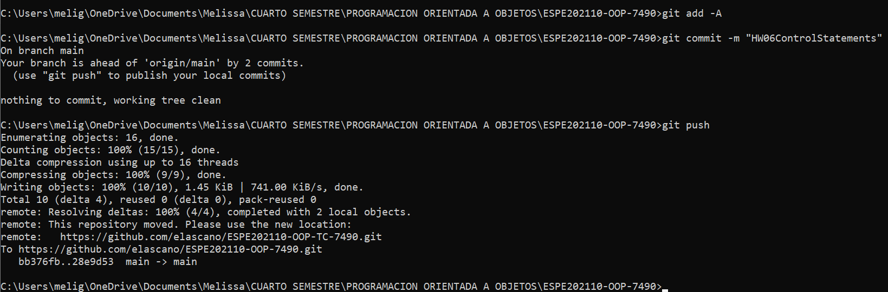

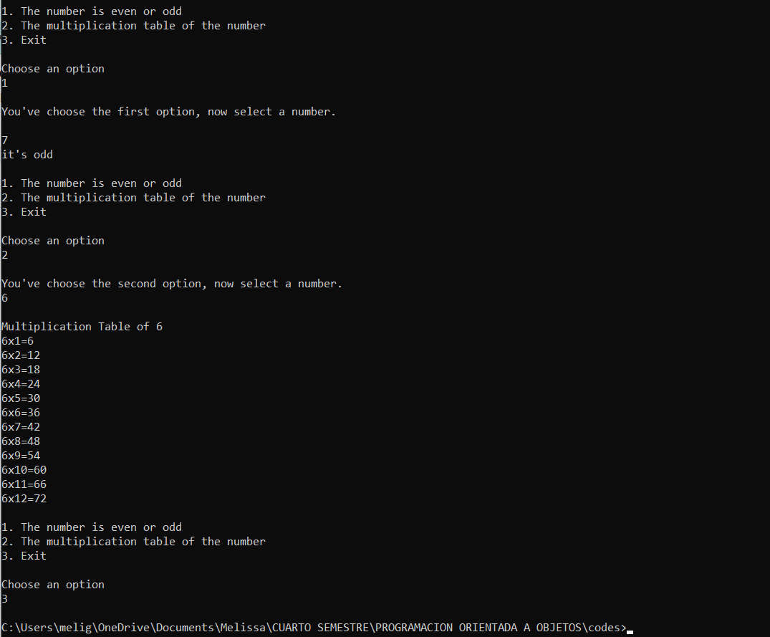

20 GUAMAN VEJARANO ANGEL DAVID

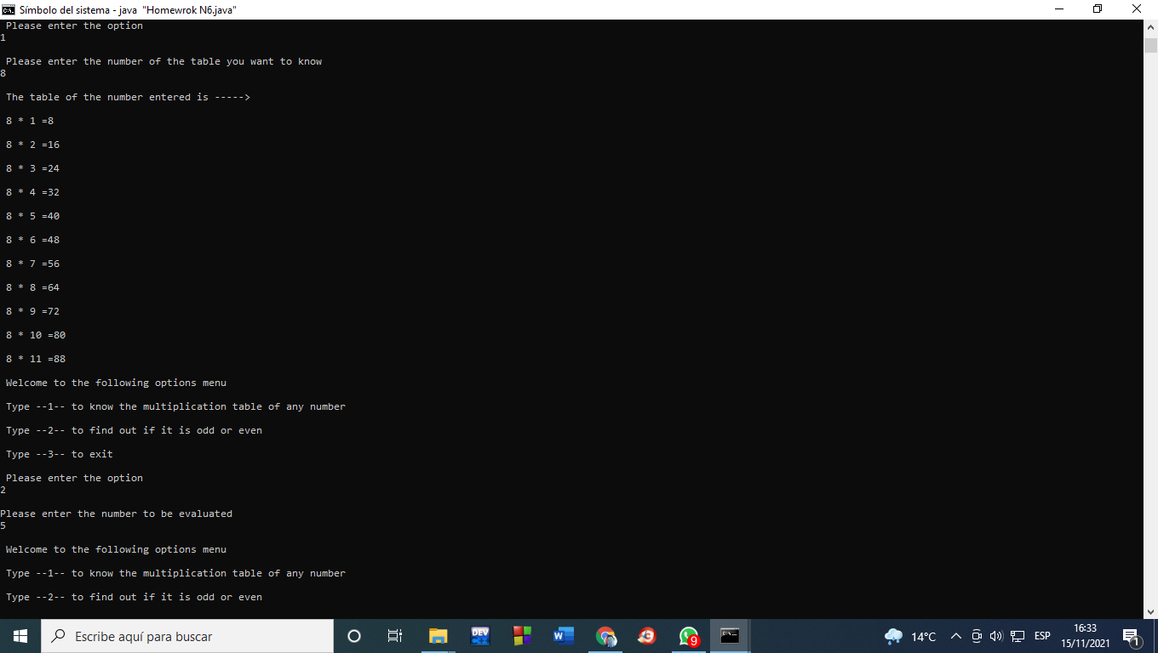

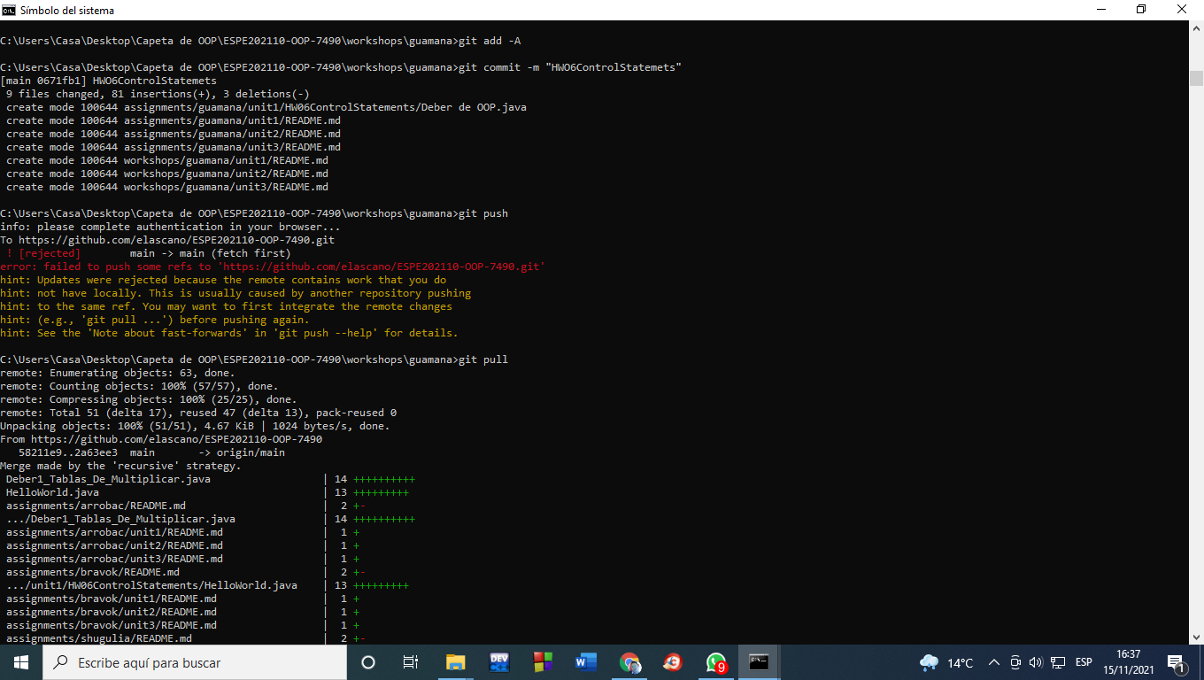

21 GUITARRA SANCHEZ JHON ALEXANDER

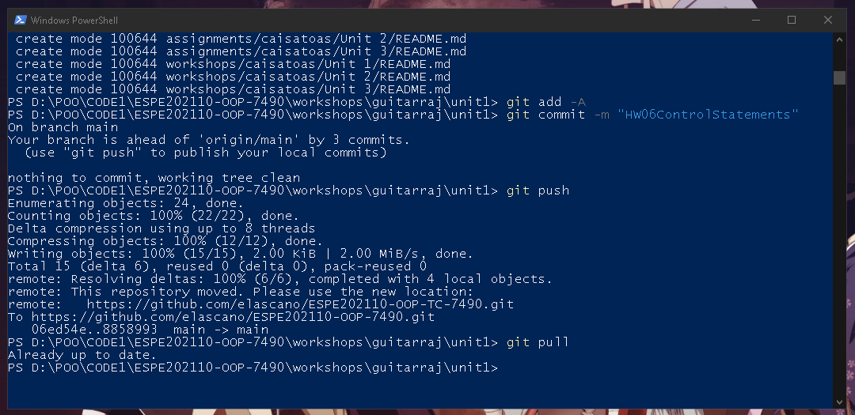

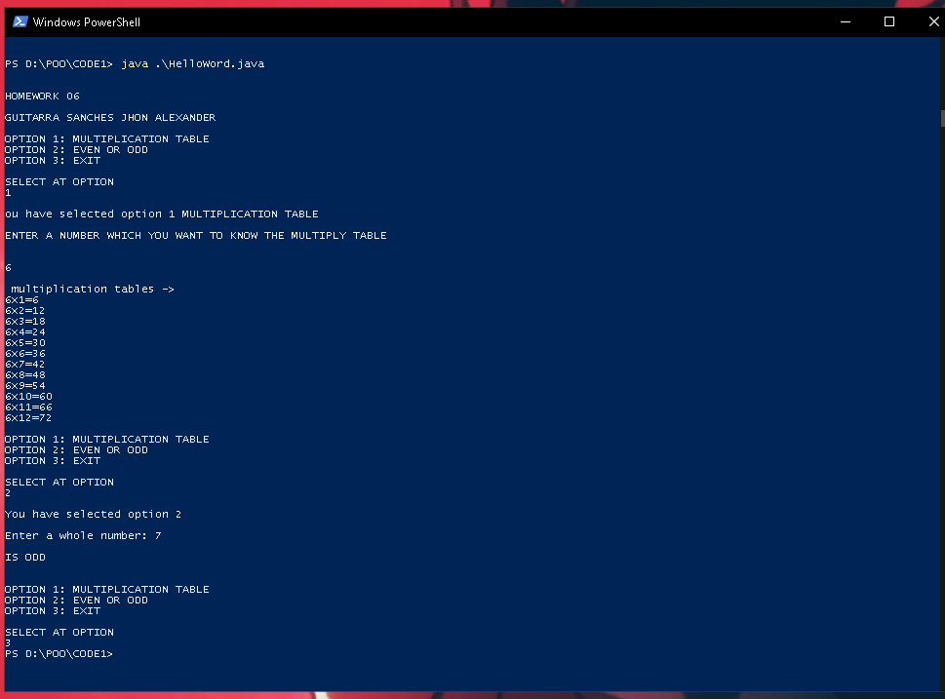

22 GUZMAN LOPEZ JOSE DAVID

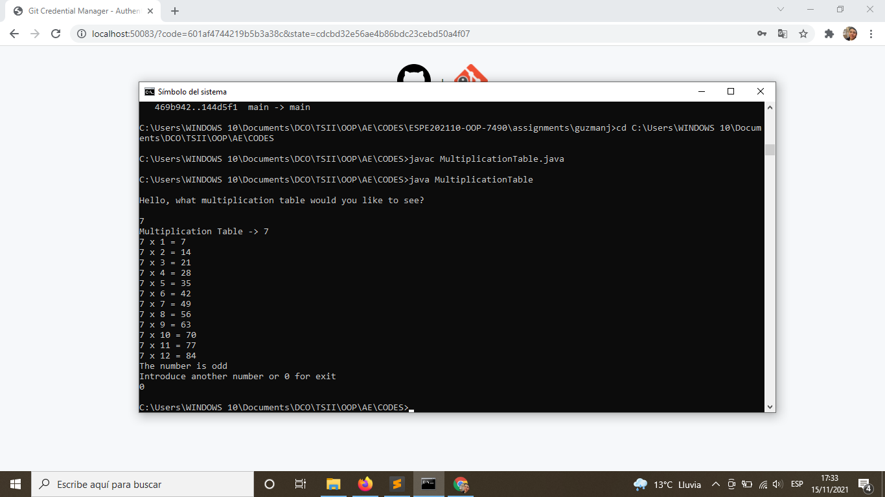

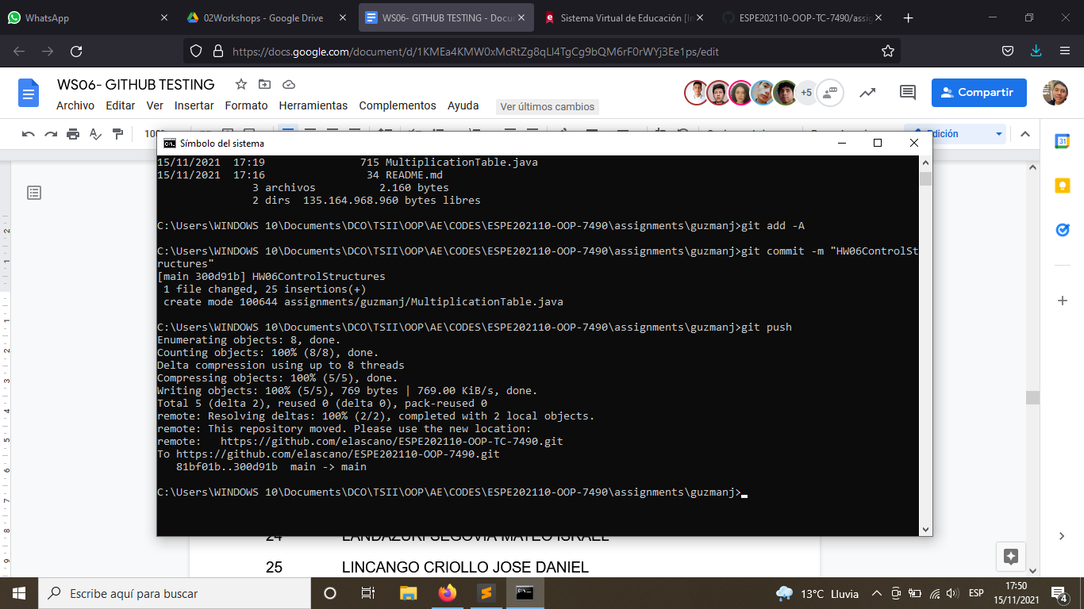

23 INSUASTI LOPEZ JONATHAN ESTEBA

24 LANDAZURI SEGOVIA MATEO ISRAEL

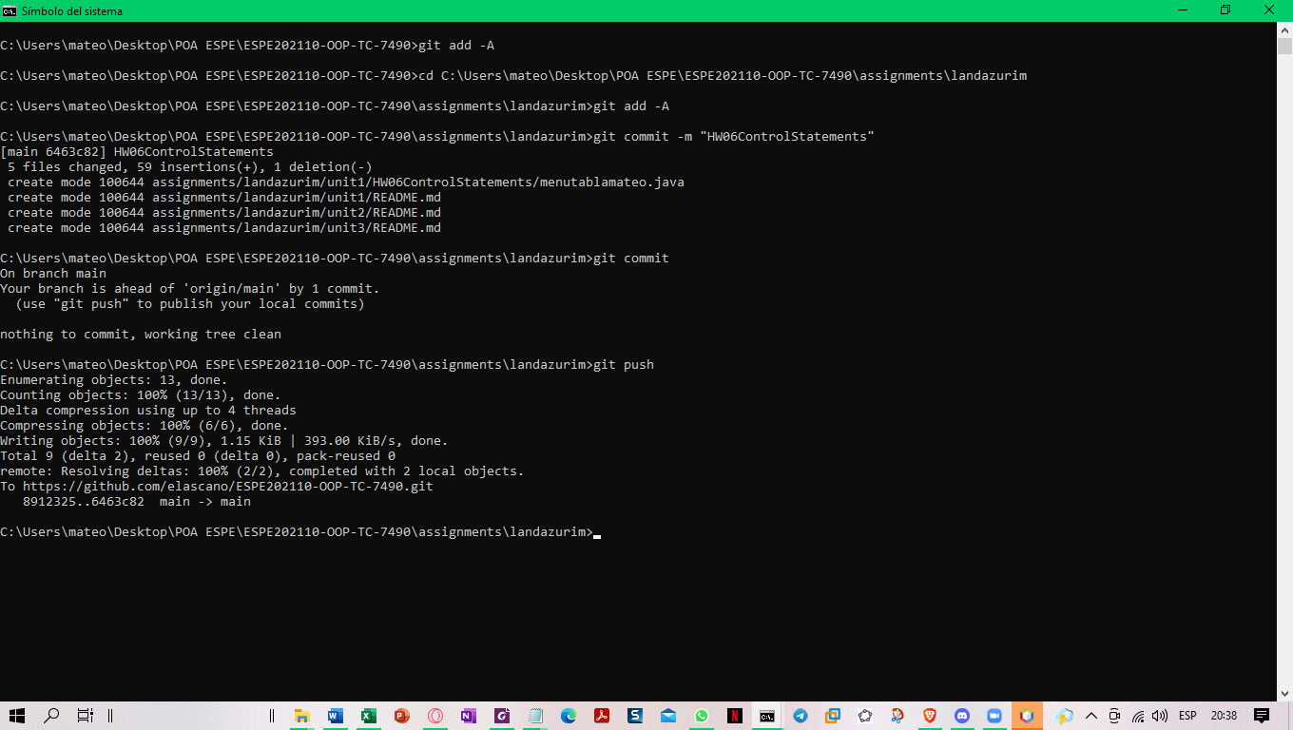

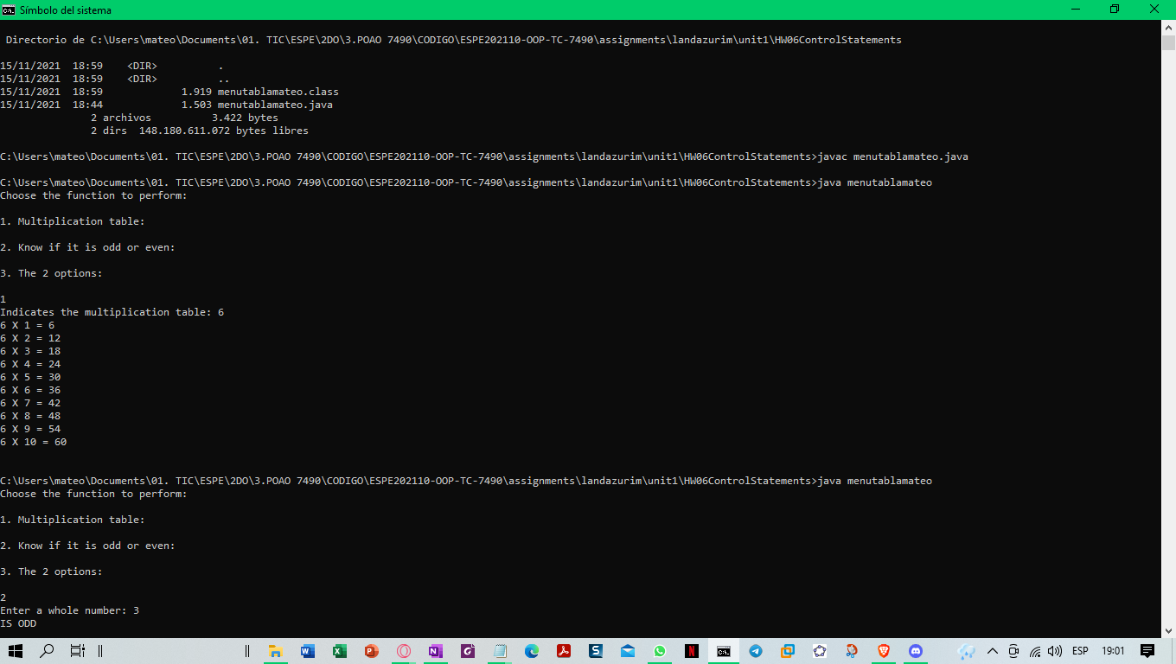

25 LINCANGO CRIOLLO JOSE DANIEL

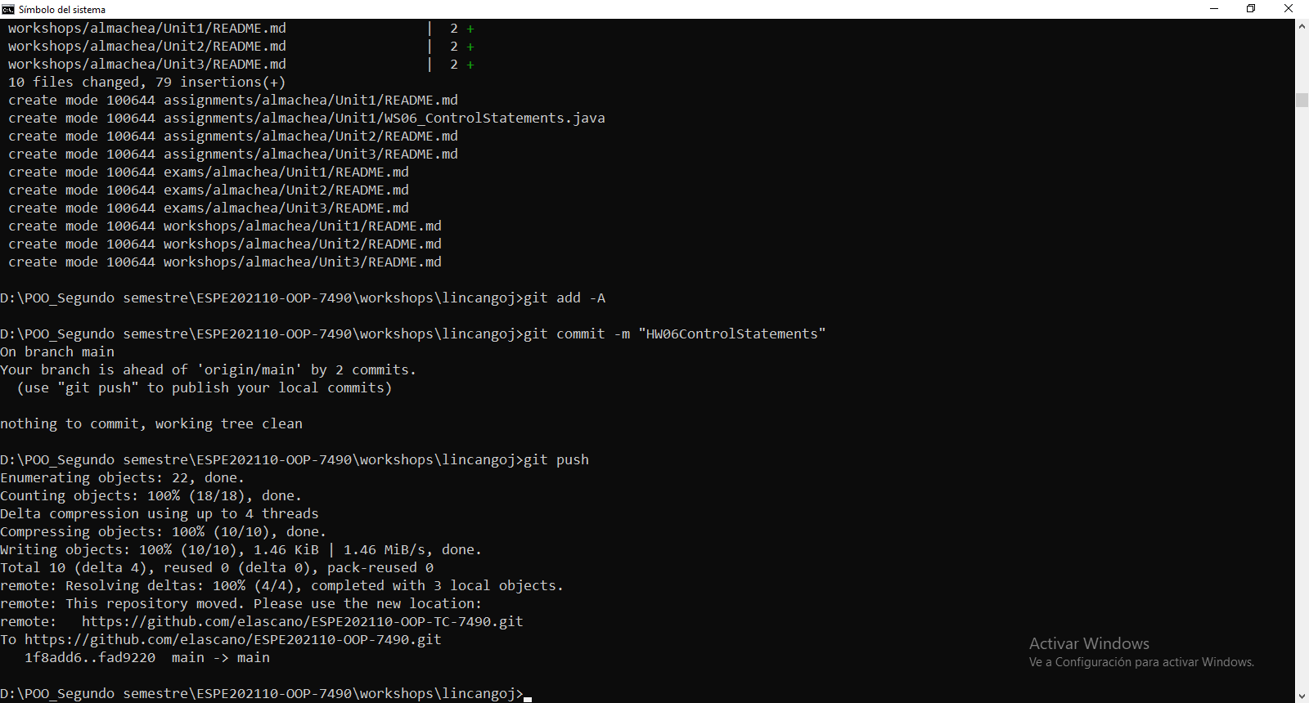

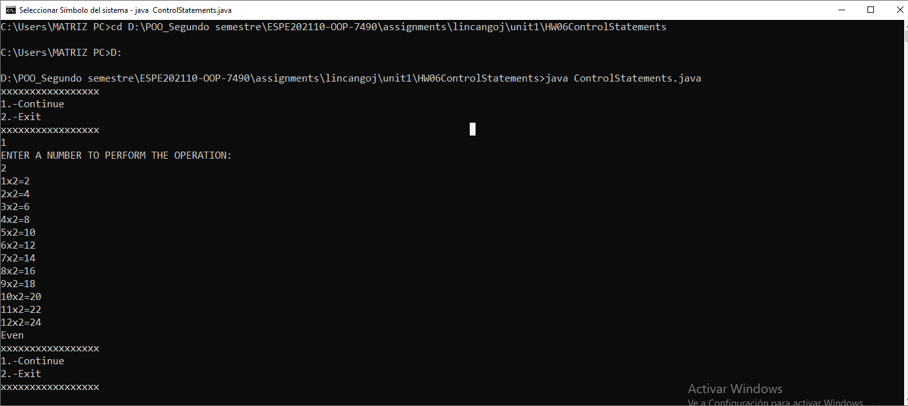

26 MAISINCHO PAUCAR RICHAR ALEXANDER

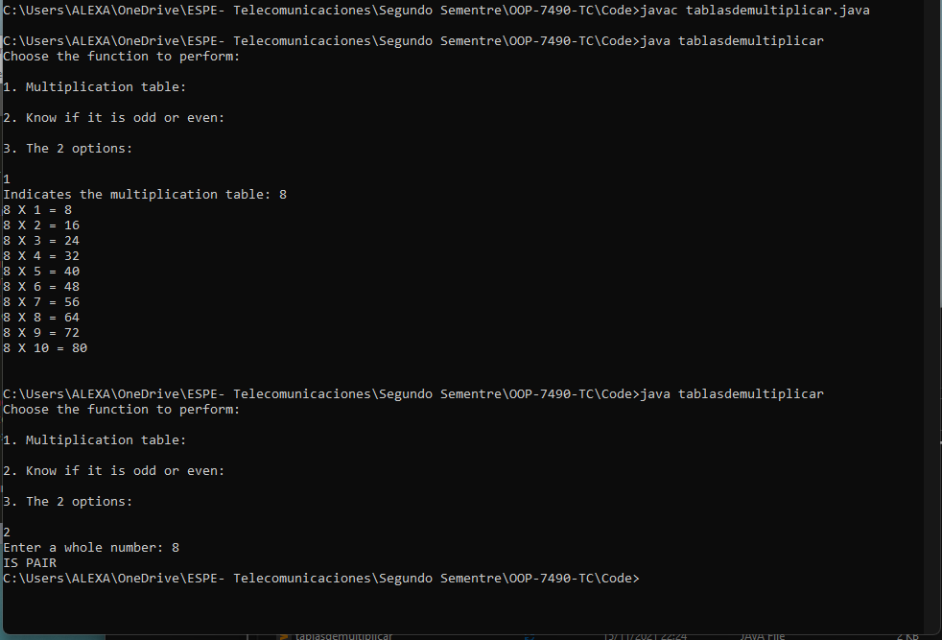

27 MALDONADO BASTIDAS MATEO STEFANO

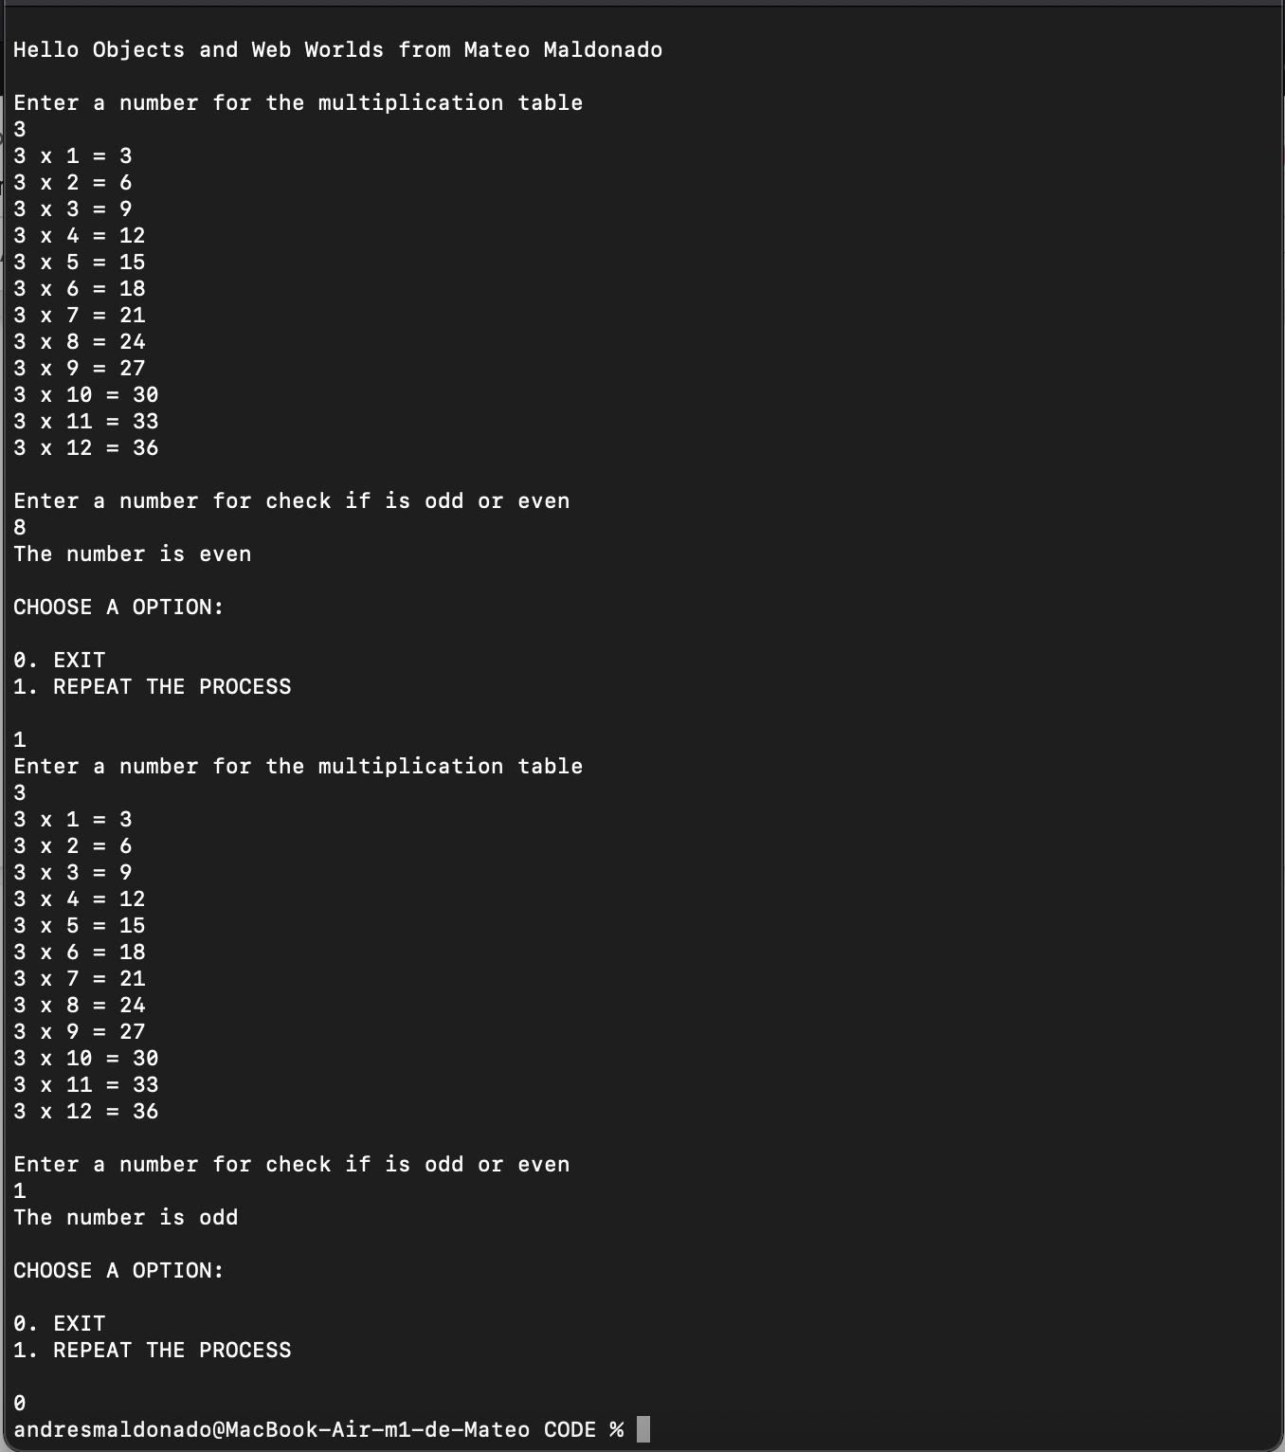

28 MANTUANO FERNANDEZ LEONEL FERNANDO

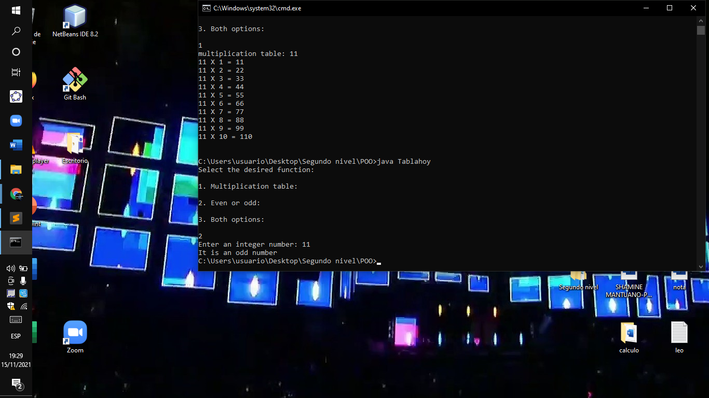

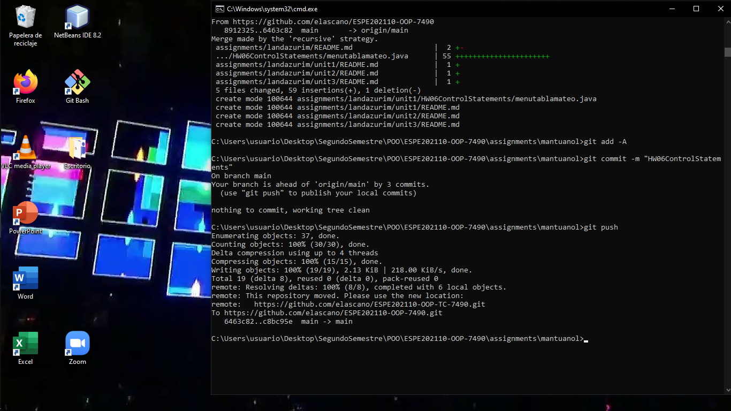

29 MORALES CAICEDO ANTHONY JAVIER

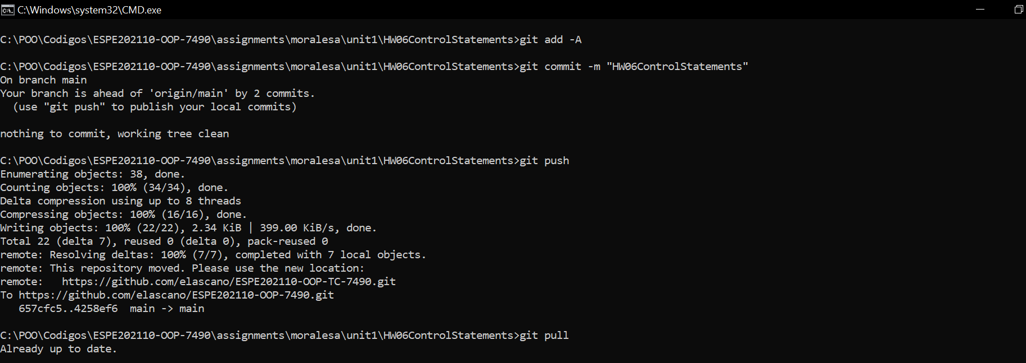

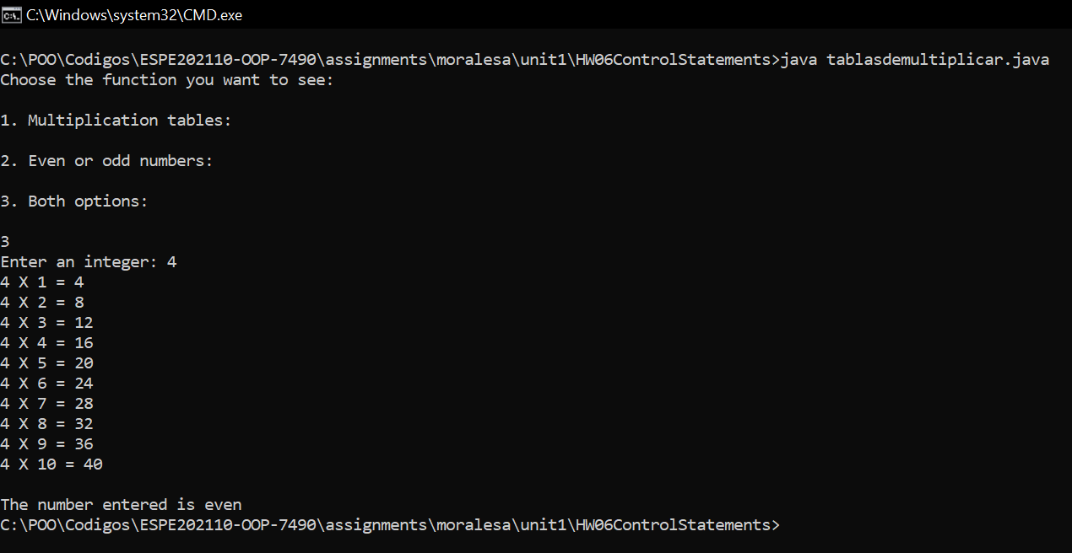

30 PALACIOS CANDO DIEGO SEBASTIAN

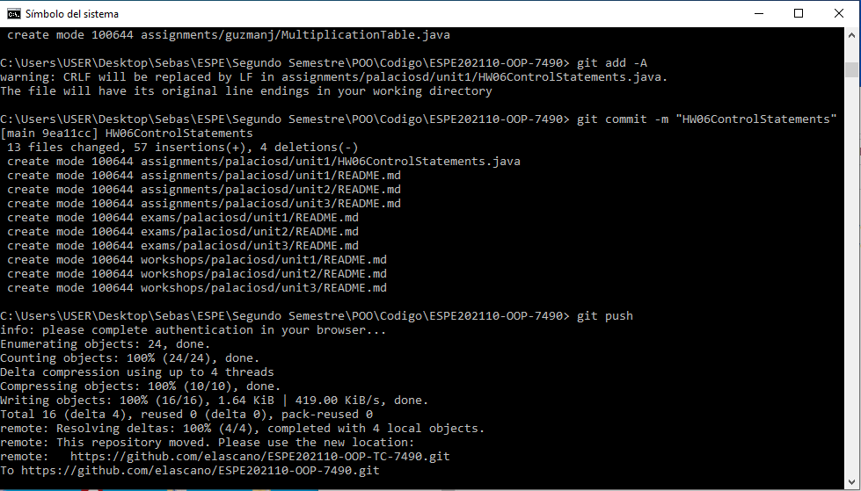

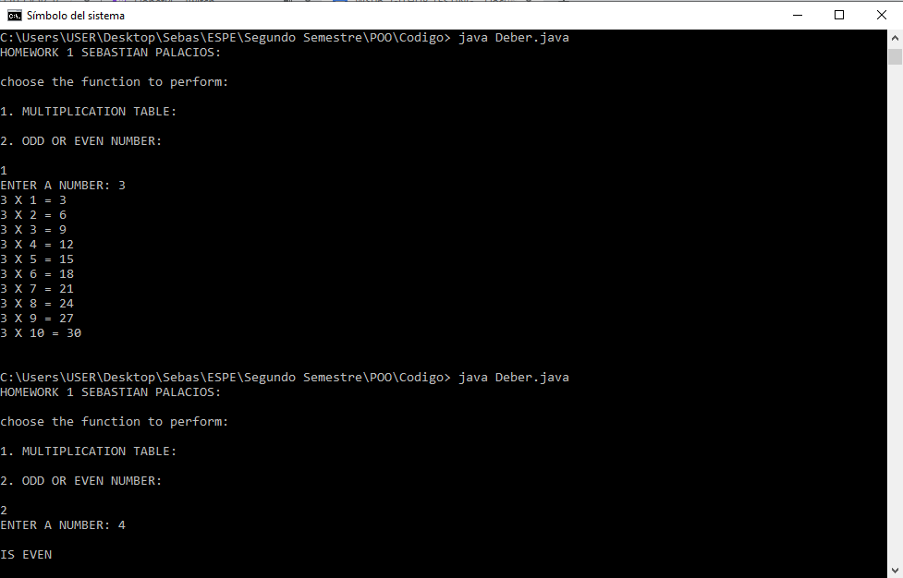

31 PAUCAR LEMA ALEX JAVIER

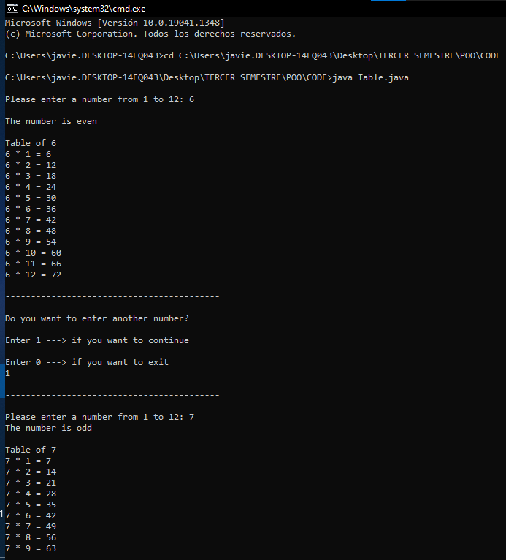

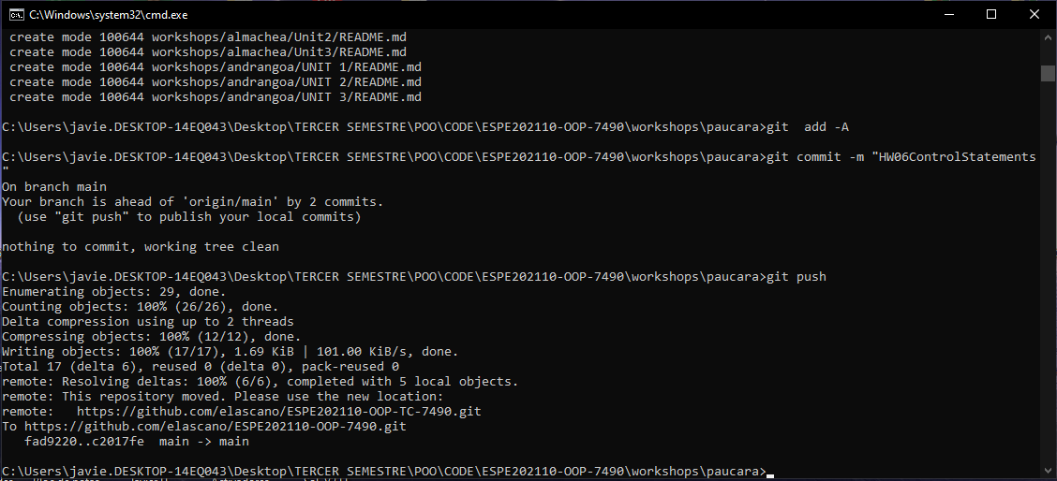

32 QUINGA GUAYASAMIN LEANDRO ALEXANDER

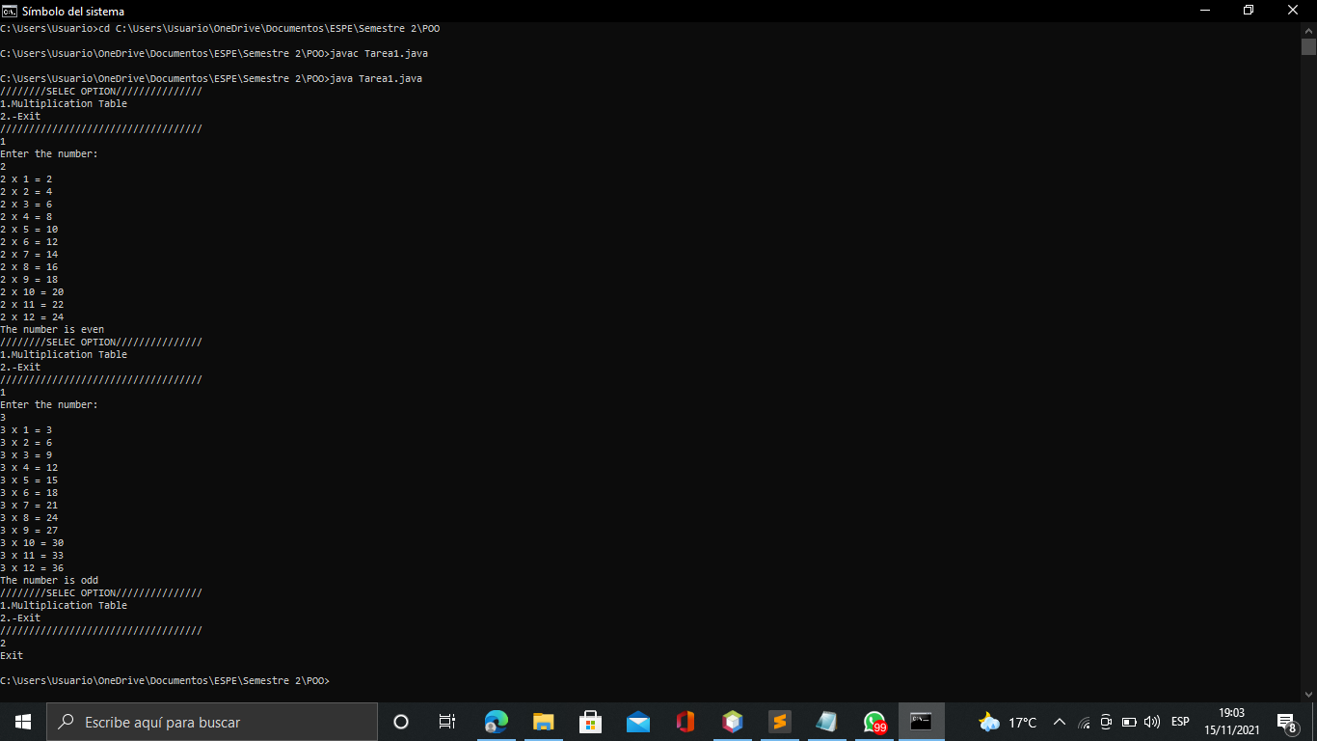

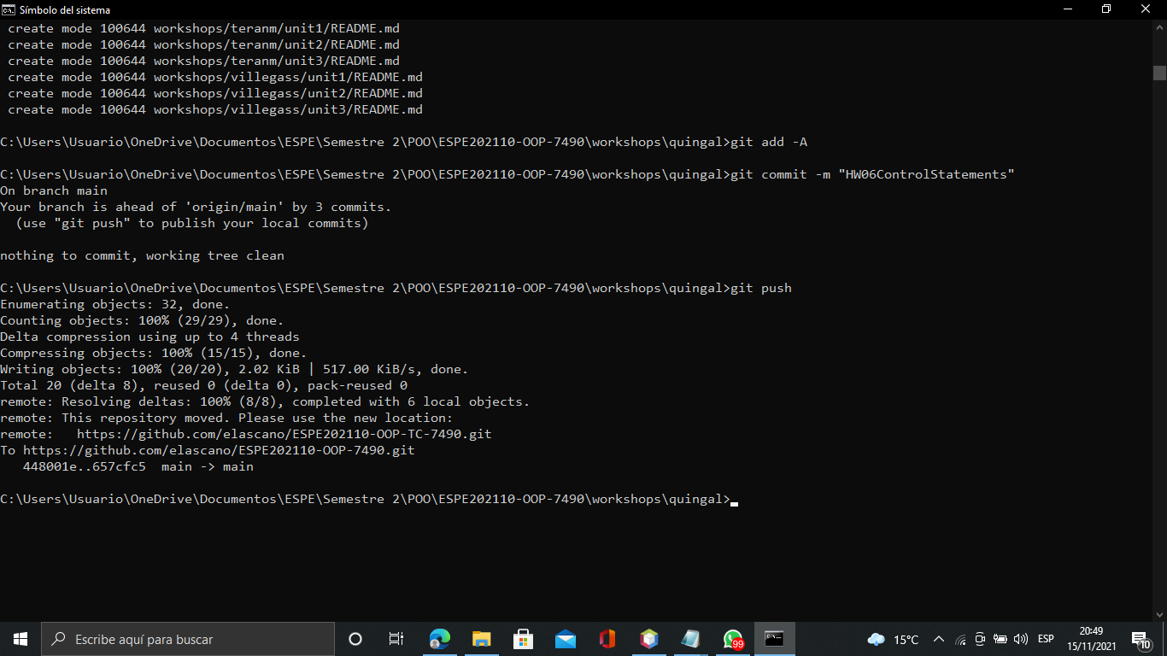

33 RUANO PONCE ALEXANDER JAVIER

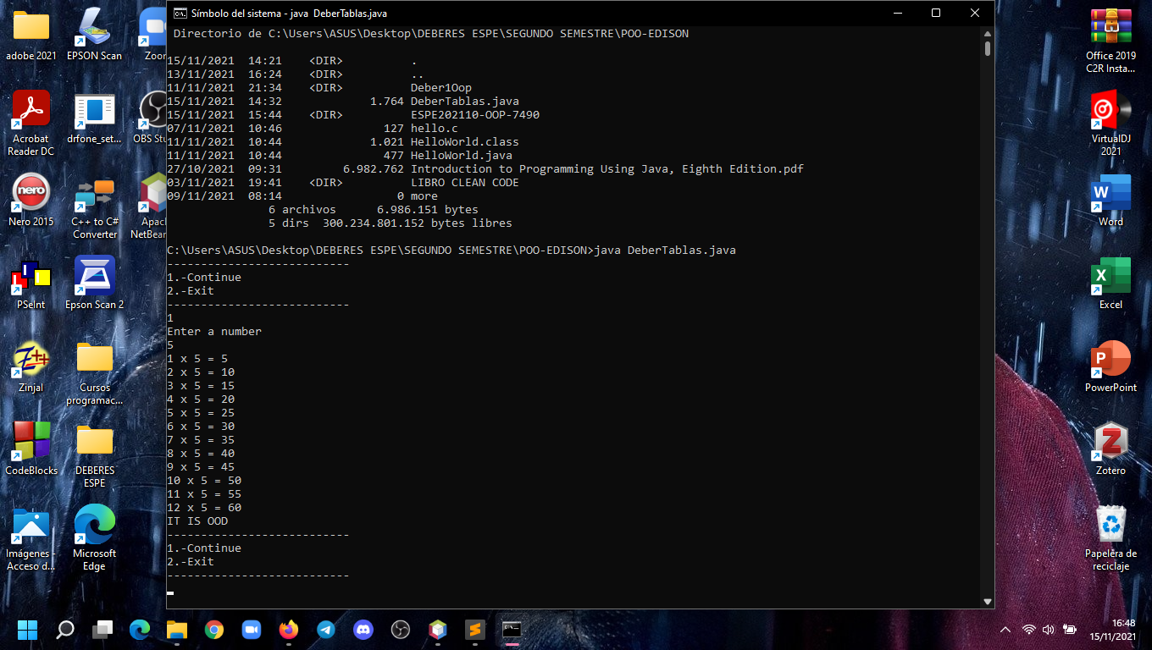

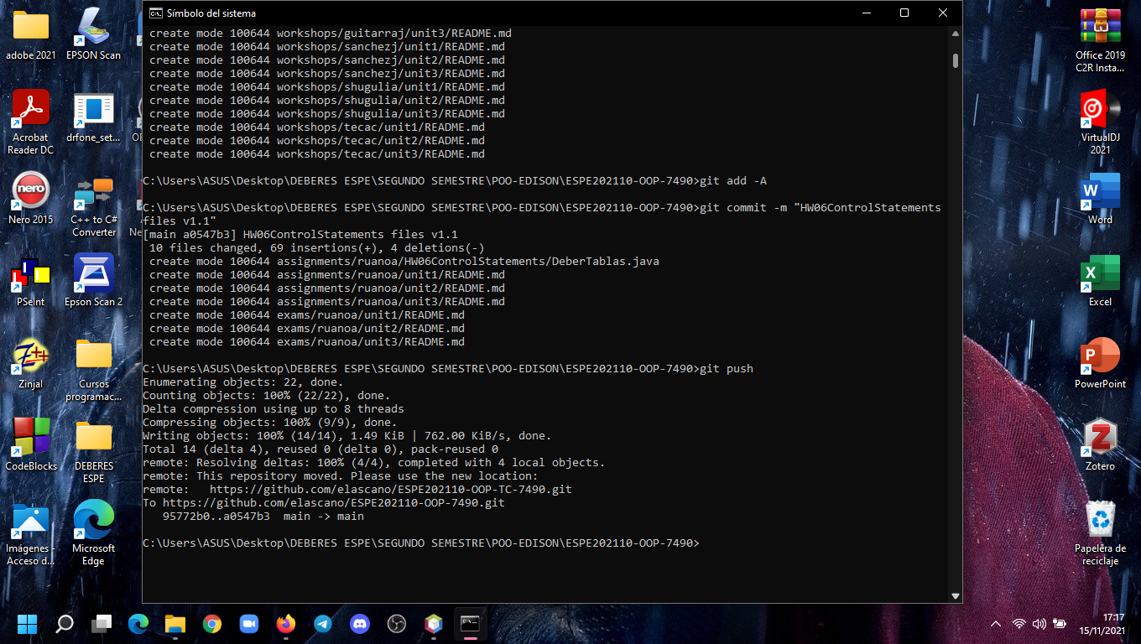

34 SALTOS TACO PAUL ALEXANDER

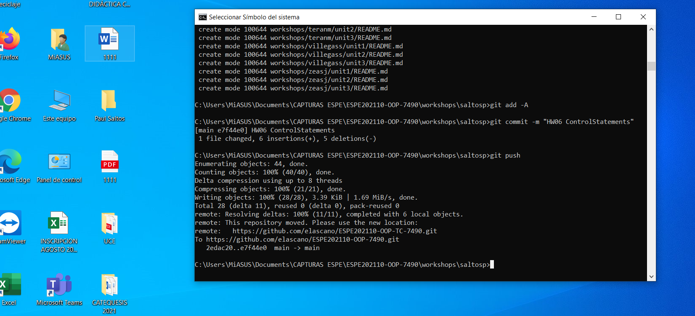

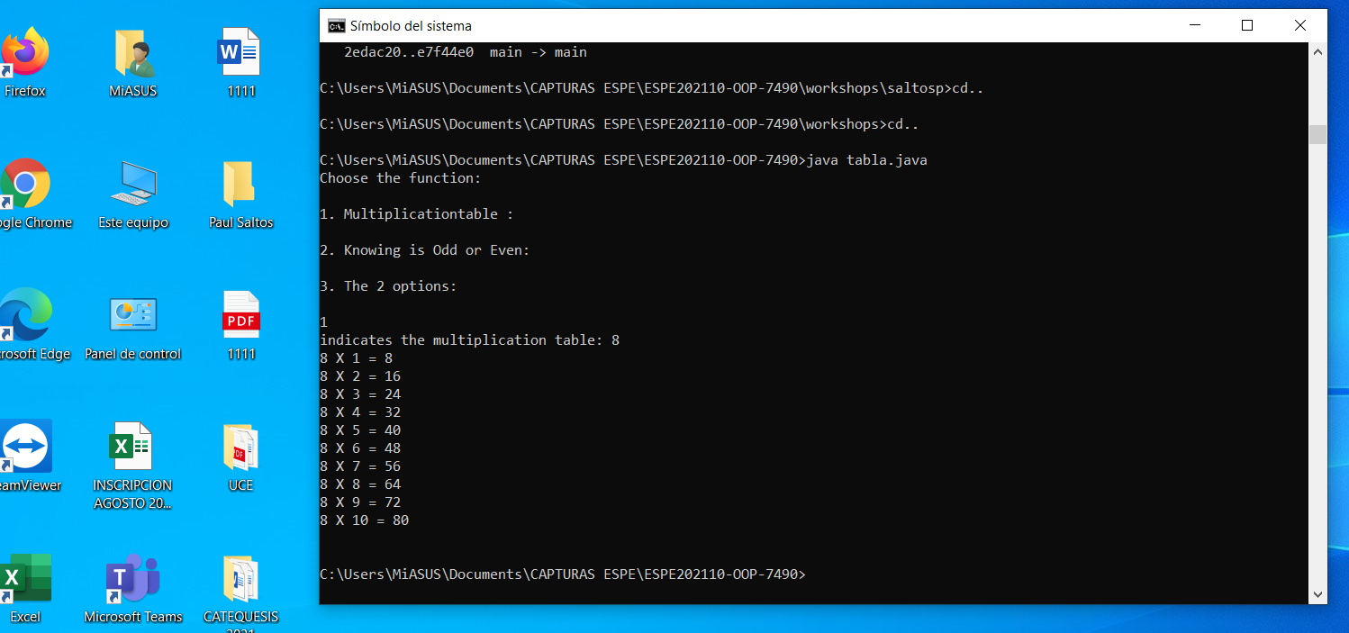

35 SANCHEZ MISHQUERO JOSE FRANCISCO

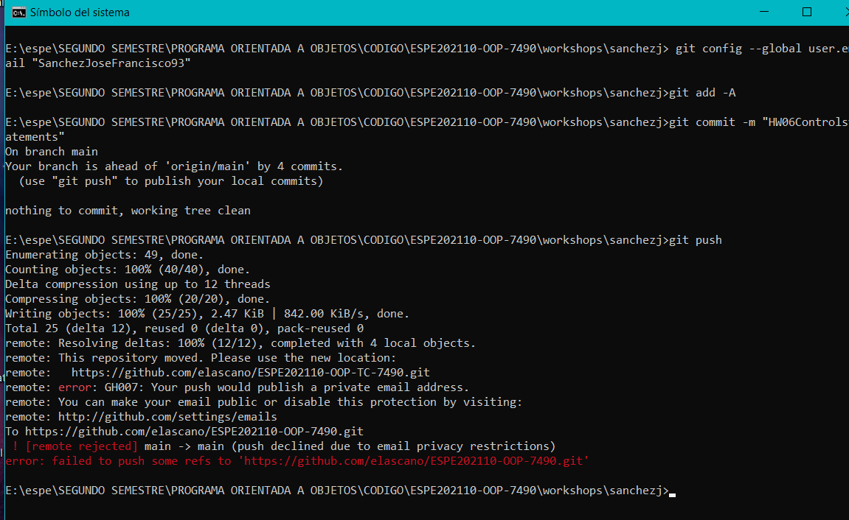

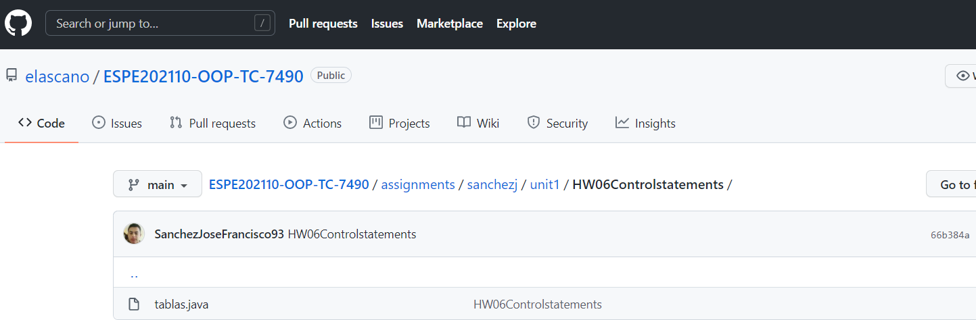

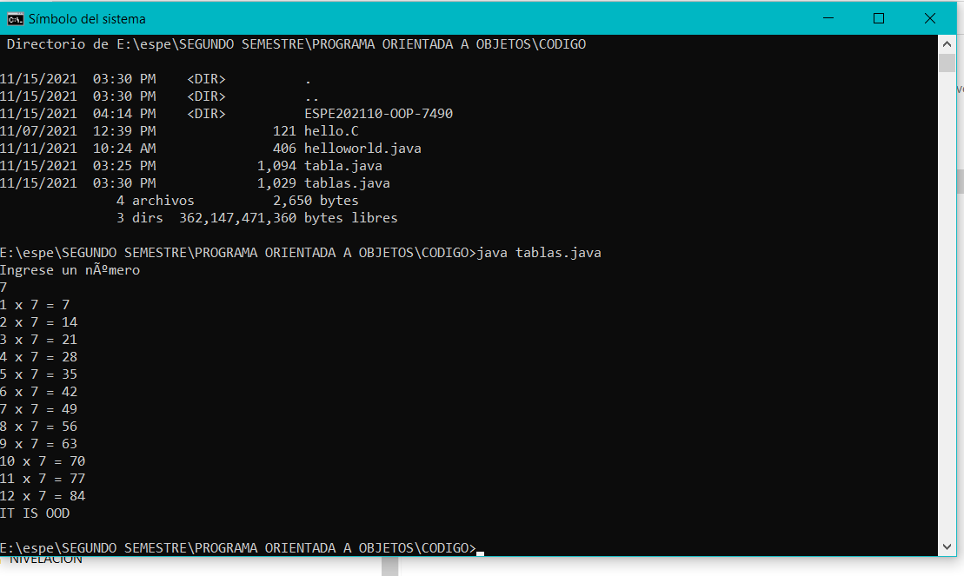

36 SHUGULI REINOSO ALAN JESITH

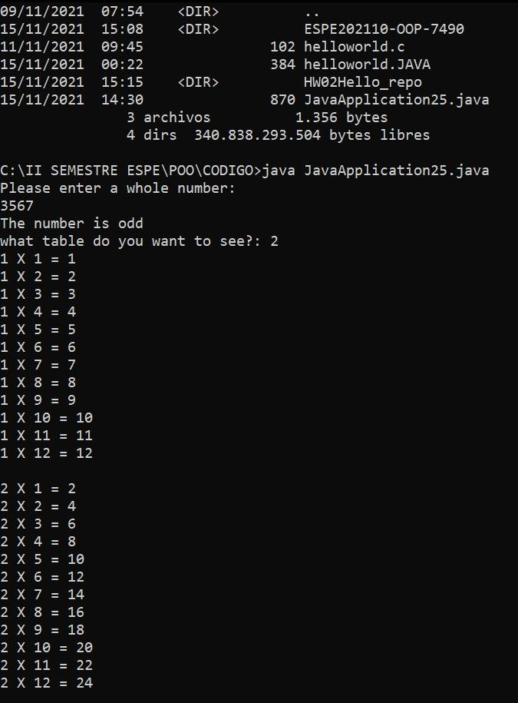

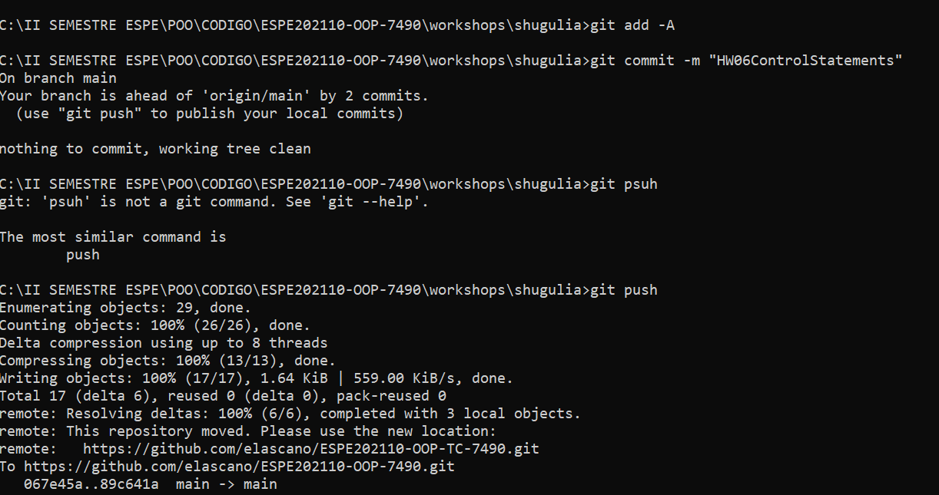

37 SIMBAÑA SIMBAÑA JONATHAN GUSTAVO

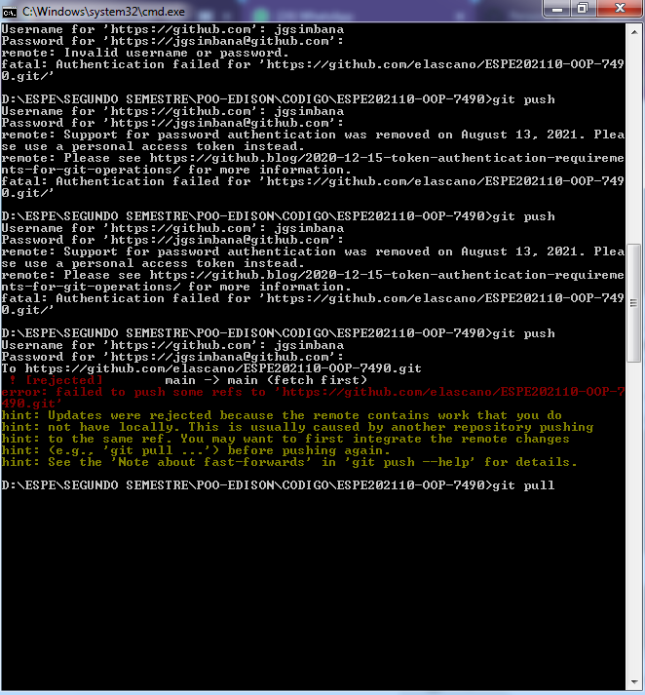

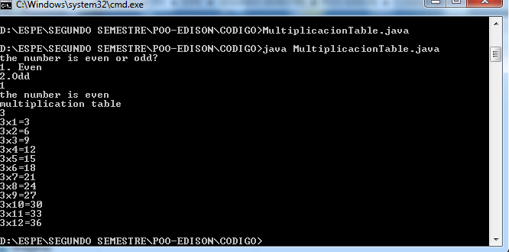

38 TAPIA ALBAN ANDREA JULIANNA

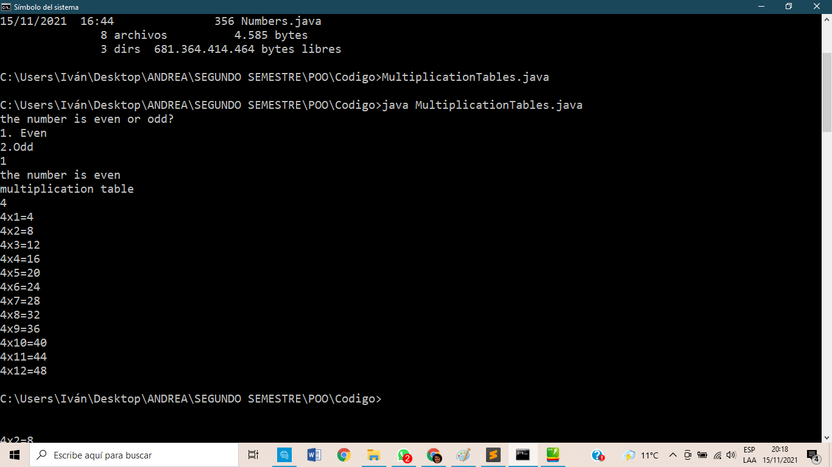

39 TAYO RUIZ SEBASTIAN ALEJANDRO

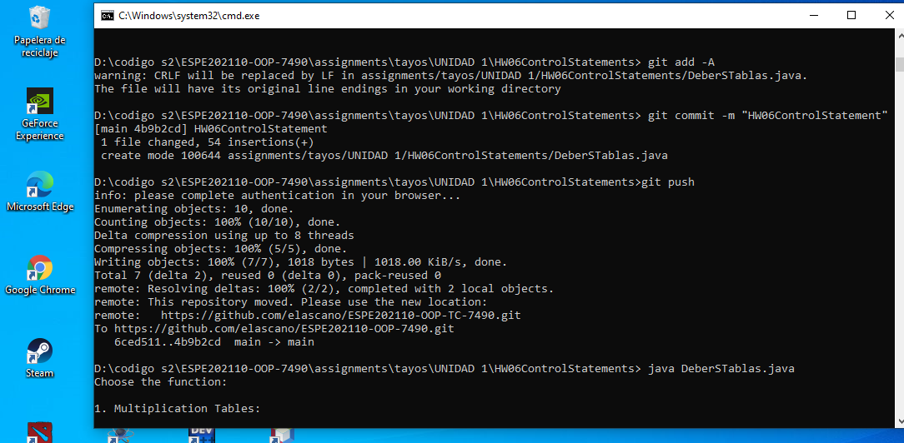

40 TECA TELLO CAMILA MILENA

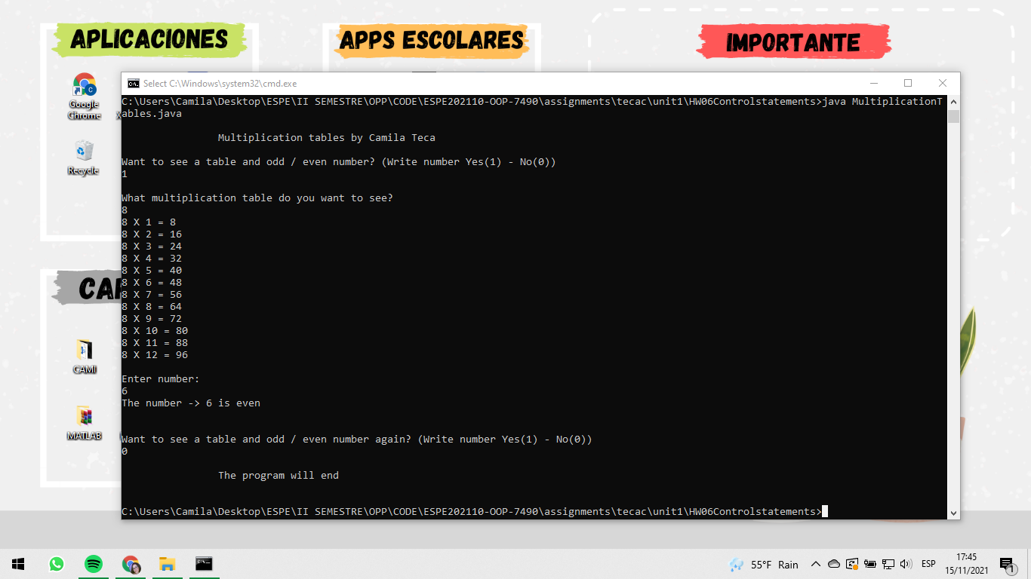

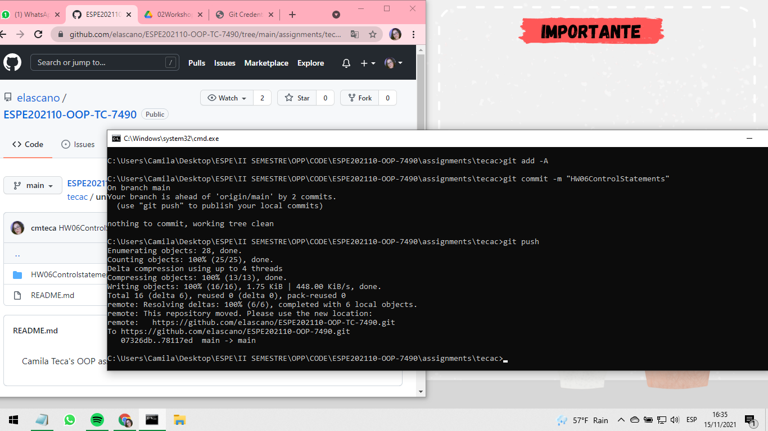

41 TERAN FLORES MELANIE ELIZABETH

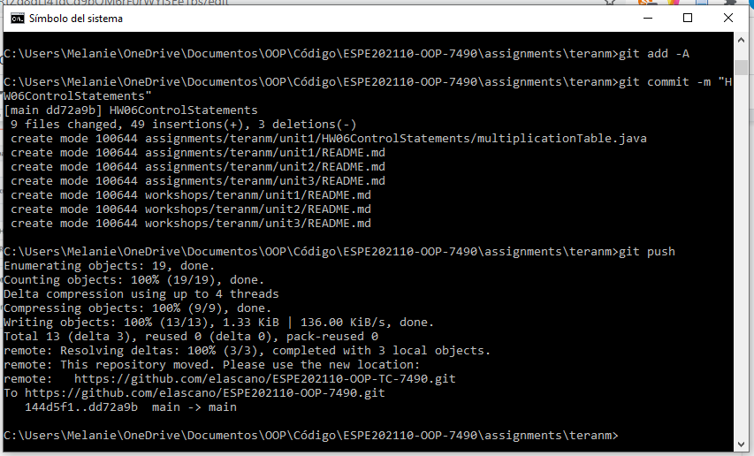

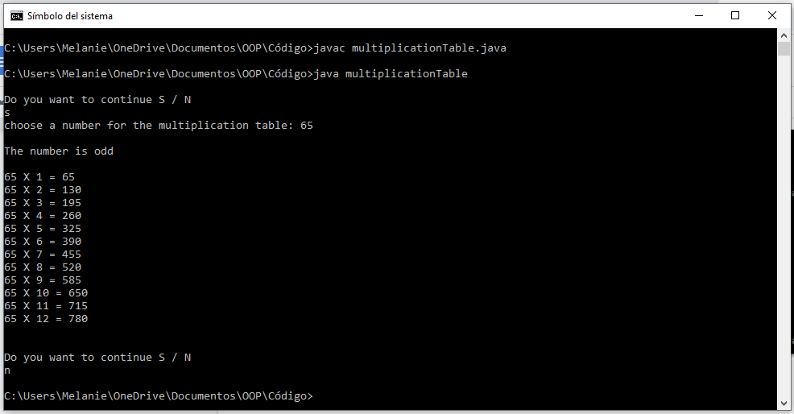

42 VILLEGAS ESTRELLA SALMA ABIGAIL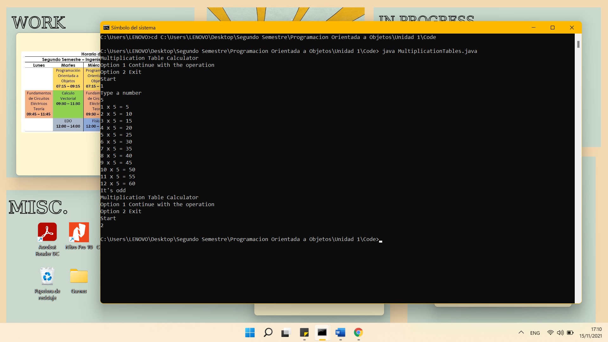

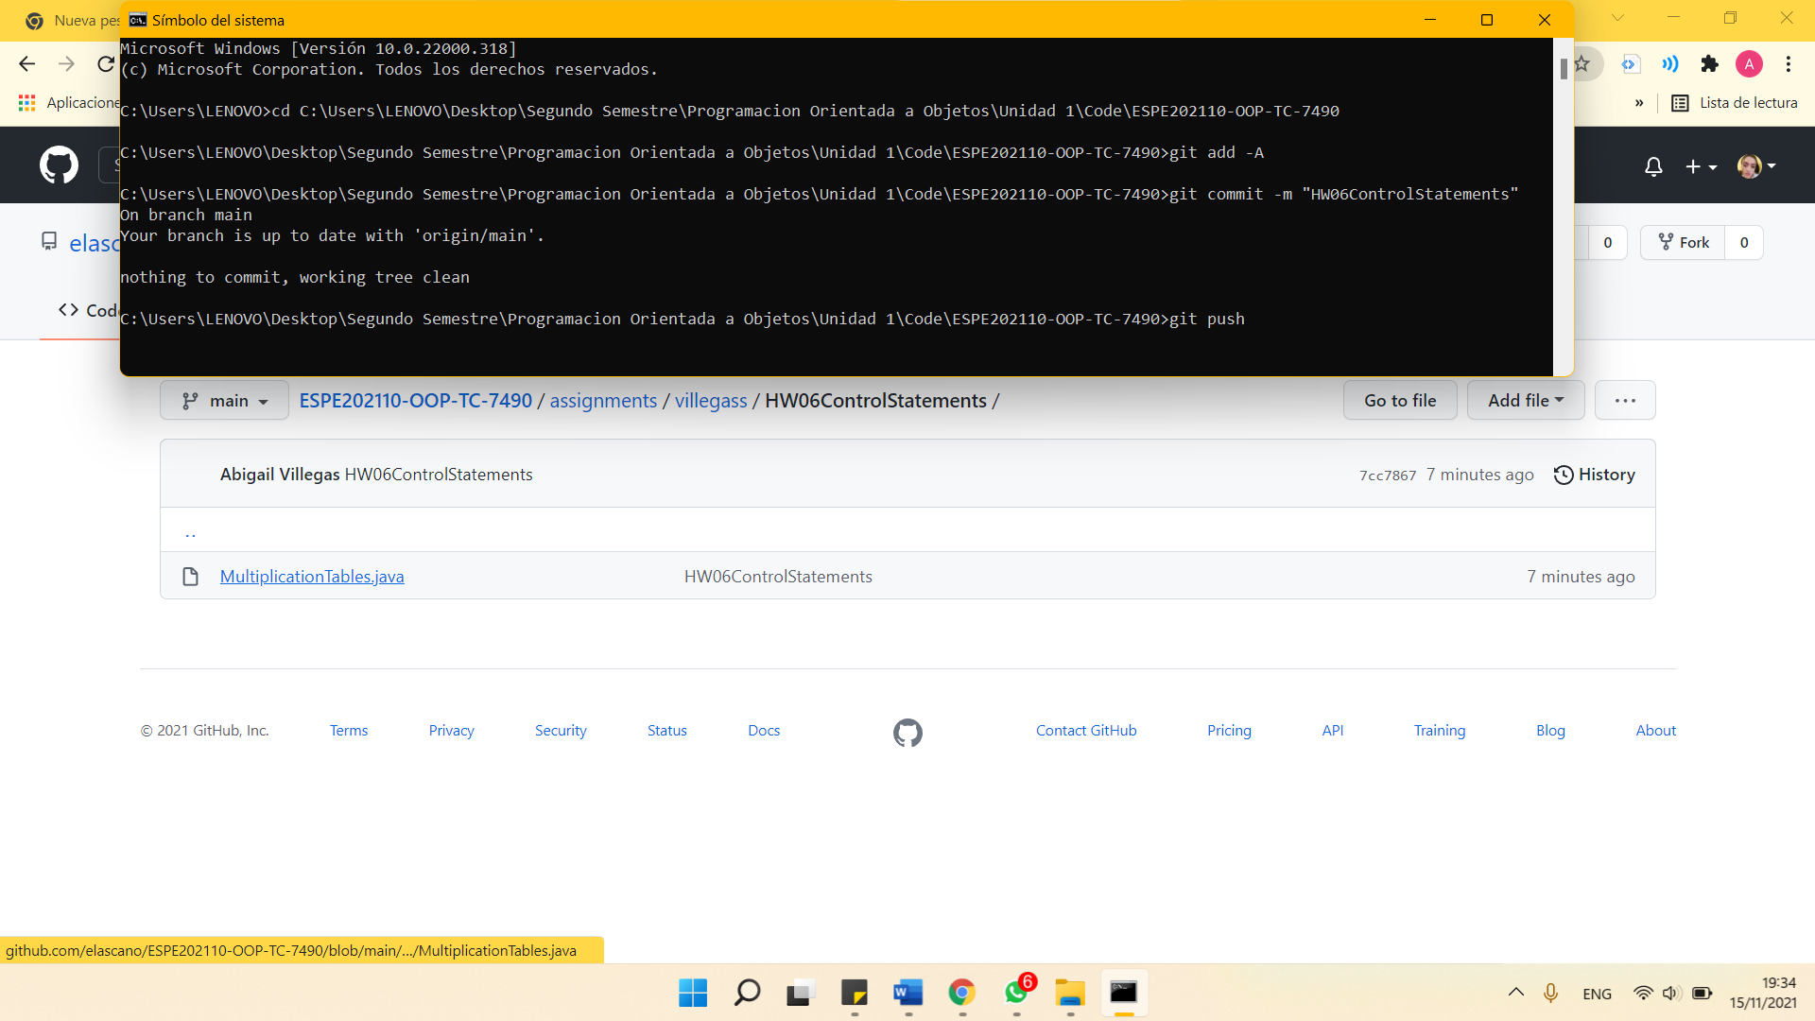

43 ZEAS CLAVIJO JOEL ALEXANDER

